**CHAPTER 1**

**INTRODUCTION**

**1.1 Problem definition**:

The exoskeletal assistive device is a type of wearable robot that uses the synchronization of the human and the robot. In this area, there has been much research ranging from the rehabilitation equipment for muscle disease patients to the power-amplifying devices for the soldiers who carry heavy military equipment [1]– [3]. As society now has more elderly than ever, it will encounter the lack of young people who support them physically and financially. Studies show that old people with gait disorders will have problems while standing and sitting and the gait pattern is also changed to support weakened bones and muscles [4][5]. This make elderly to take physical assistance for their normal gait which on time being will affect their psychological confidence to walk without help [6]. Robotic research will contribute to solve some of the problems of the aging society. The wearable robot may be a solution that helps elderly people to live without the physical assistance of young people. Also, the wearable robot can help the rehabilitation of patients who have nervous and muscular diseases.

This project deals with the study of gait patterns in older adults and designing a suitable Exoskeleton for assistance while sitting, standing and walking of elderly. Individual study is made on different available designs to understand the advantages and the limitations of each design. In this project the design of various possible models of exoskeletons is studied and an assistive exoskeleton is designed. Static Structural analysis and modal analysis for the design was done to check whether the design is structurally safe. The final design is expected to solve the above gait related problems in elderly.

**1.2 Wearable Robots and Exoskeletons:**

Wearable robots are person-oriented robots. They can be defined as those worn by human operators, whether to supplement the function of a limb or to replace it completely. Wearable robots may operate alongside human limbs, as in the case of orthotic robots or exoskeletons, or they may substitute for missing limbs, for instance following an amputation. Wearability does not necessarily imply that the robot is ambulatory, portable or autonomous. Where wearable robots are nonambulatory, this is in most instances a consequence of the lack of enabling technologies, in particular actuators and energy sources. A wearable robot can be seen as a technology that extends, complements, substitutes or enhances human function and capability or empowers or replaces (a part of) the human limb where it is worn. A possible classification of wearable robots takes into account the function they perform in cooperation with the human actor.

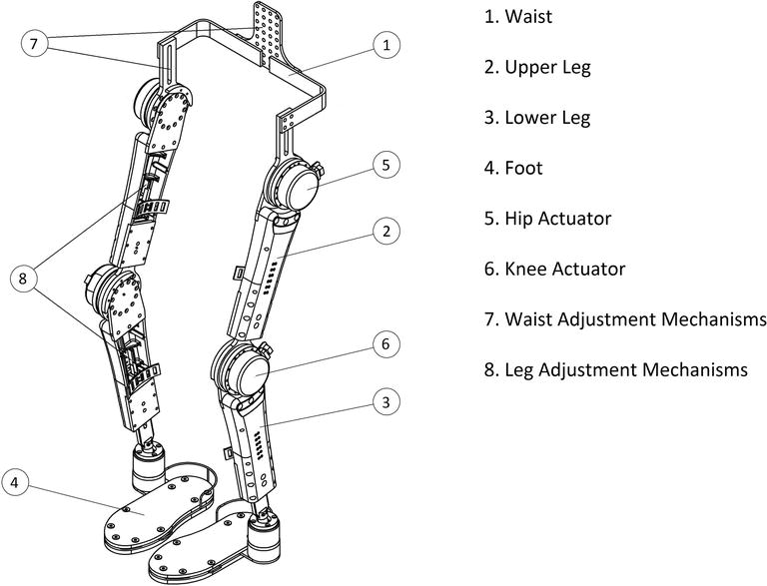

Figure.1.1 Lower limb Exoskeleton

**1.3 Importance of Gait:**

Walking is a common activity of daily living and at the same time a very complex one. It involves all levels of the nervous system and many parts of the musculoskeletal apparatus as well as the cardiorespiratory system. A person’s gait pattern is strongly influenced by age, personality and mood. Moreover, sociocultural factors play a role: for instance, persons living in large cities walk significantly faster than those living in rural areas [8]. The prevalence of gait and balance disorders markedly increase with age, from around 10% between the ages of 60 and 69 years to more than 60% in those over 80 years. Walking is a sensitive indicator of overall health status and the self-selected walking speed closely correlates with individual life expectancy in elderly persons [9]. Importantly, slow gait in elderly non-demented persons correlates more closely with the future emergence of dementia than subjective cognitive impairment [10, 11].

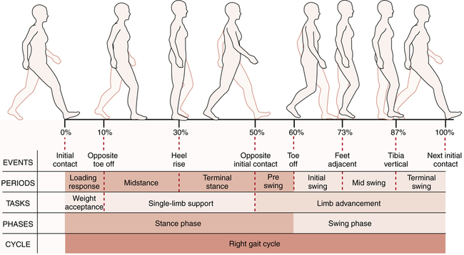

Figure.1.2 Gait cycle

**1.4 Normal Age-Related Changes in Gait:**

For the elderly, walking, standing up from a chair, turning, and leaning are necessary for independent mobility. Gait speed, chair rise time, and the ability to do tandem stance (standing with one foot in front of the other—a measure of balance) are independent predictors of the ability to do instrumental activities of daily living (eg, shopping, traveling, cooking) and of the risk of nursing home admission and death. Walking without assistance requires adequate attention and muscle strength plus effective motor control to coordinate sensory input and muscle contraction.

**1.4.1 Gait velocity:**

speed of walking remains stable until about age 70; it then declines about 15%/decade for usual gait and 20%/decade for fast walking. Gait velocity is a powerful predictor of mortality—as powerful as an elderly person's number of chronic medical conditions and hospitalizations. At age 75, slow walkers die ≥ 6 yr earlier than normal velocity walkers and ≥ 10 yr earlier than fast velocity walkers. Gait velocity slows because elderly people take shorter steps at the same rate (cadence). The most likely reason for shortened step length (the distance from one heel strike to the next) is weakness of the calf muscles, which propel the body forward; calf muscle strength is substantially decreased in elderly people. However, elderly people seem to compensate for decreased lower calf power by using their hip flexor and extensor muscles more than young adults.

**1.4.2 Cadence:**

Reported as steps/min does not change with aging. Each person has a preferred cadence, which is related to leg length and usually represents the most energy-efficient rhythm. Tall people take longer steps at a slower cadence; short people take shorter steps at a faster cadence.

**1.4.3 Double stance time:**

Time with both feet on the ground during ambulation—a more stable position for moving the center of mass forward) increases with age. The percentage of time in double stance goes from 18% in young adults to ≥26% in healthy elderly people. Increased time in double stance reduces the time the swing leg has to advance and shortens step length. Elderly people may increase their double stance time even more when they walk on uneven or slippery surfaces, when they have impaired balance, or when they are afraid of falling. They may appear as if they are walking on slippery ice.

**1.4.4 Walking posture:**

Walking posture changes only slightly with aging. Elderly people walk upright, with no forward lean. However, elderly people walk with greater anterior (downward) pelvic rotation and increased lumbar lordosis. This posture change is usually due to a combination of weak abdominal muscles, tight hip flexor muscles, and increased abdominal fat. Elderly people also walk with their legs rotated laterally (toes out) about 5°, possibly because of a loss of hip internal rotation or in order to increase lateral stability. Foot clearance in swing is unchanged with advancing age.

**1.4.5 Joint motion:**

Joint motion changes slightly with aging. Ankle plantar flexion is reduced during the late stage of stance (just before the back foot lifts off). The overall motion of the knee is unchanged. Hip flexion and extension are unchanged, but the hips have increased adduction. Pelvic motion is reduced in all planes.

**CHAPTER 2**

**LITERATURE SURVEY**

**2.1 Exoskeleton Design requirements:**

Walking is a vital human function, it helps human beings to accomplish everyday tasks. Though gait in human beings looks lucid, it requires a cascade of neural and muscular interactions. Gait abnormalities will not only have negative effects on physical abilities but also on cognitive abilities. For instance, it will bring down the confidence level of the person to complete day-to-day tasks and added to that low physical activity when compared with the food intake, may make the person obese [7]. Old people with gait disorders will have problems while standing and sitting and their gait pattern will also change to support weakened bones and muscles. According to a study on gait patterns in older adults, at 60, 85% of seniors have a normal gait and this percentage drops to 18% by age of 85. [8] There are many medical reasons for these gait disorders, one such reason is Osteoporosis. It is a condition where the bone density will get depleted with much more porous internal bone structure. This leads to reduced bone strength with more possibility of bone fractures due to falls. To reinforce the weakened bones during the sit-to-stand cycle and walking, external aids like walkers and crutches are used by elderly. Though the crutches help in mobility, it will reduce the walking speed of the person and besides adds on more effort on upper body. A much efficient way is to have an assistive device which reduces the wearer’s efforts on the upper body concomitantly obtaining better walking speeds. Since the major part of the muscles, nerves, bones, and tendons involved in the mobility are present in the lower body and to maximise the safety by reducing the accidents with environment and operator, an ideal exoskeleton design will be a Lower limb exoskeleton. The wearable Assistive Exoskeletons can solve the mobility problems in seniors to live without the physical help of other people [9]. With the rapid growth of study in the area of Human and Robot Interactions(HRI), distinct exoskeleton designs were developed relying on the type of movability problems. Exoskeletons are classified as Powered Exoskeletons, Passive Exoskeletons, Pseudo-Passive Exoskeletons, and Hybrid Exoskeletons which will be contingent on kind of driving mechanism and its functions. A Phenomenal amount of research work has been done on the area of Powered Exoskeletons differing from rehabilitation Exoskeletons like ReWalk to the Power-enhancing Exoskeletons like HAL [10] and BLEEX [11] by the HRI and robotic communities around the globe [12]. In this paper, the Assistive Exoskeleton design comes under the class of Powered Exoskeletons as it uses sensors, Actuators and Battery pack to power this unit. Powered exoskeletons are used widely in the case of Spinal Cord Injury (SCI). Some of the significant exoskeletons used for rehabilitation of the SCI people are Indego, ReWalk, EXO-H2. Indego is a lower limb exoskeleton for people with paralysis due to SCI developed at Vanderbilt University. It supports people during the sit-to-stand cycle and walking along with the speed adjustments with a wireless software application developed by them [13]. ReWalk is lower extremity powered exoskeleton for people with completely paralyzed lower body. It has rehabilitation version with height and width adjustment, and a personal unit version which can be custom designed for a comfortable fit with the wearer body [14]. Exo-H2 is a powered exoskeleton which assists the people who partially lost their ability to walk. It uses Dc brushless motors coupled with Harmonic gear drive for actuation at all the six joints in the lower limb(Hip-Knee-Ankle) [15].

**2.1.1 Age group and Anthropometric data**:

Mobility efficiency of a person can be evaluated by the walking speed and falls. According to [16-17], the research results show that the walking velocity decreases with the age making the gait less efficient. Tommy Oberg tested 233 healthy subjects for their walking speed with age ranging between 10 to 79 years [18]. Hageman [19], Finley [20], waters [21] have also done experiments to find the walking speed. The average of overall velocity results for different age groups and gender with reference to the above papers are given in table 2.1.

|  |  |  |
| --- | --- | --- |
| **Gender** | **Age** | **Velocity(m/s)** |
| Male | 60-69 | 1.24 |
| Female | 60-75 | 1.09 |

Table.2.1. Walking speed comparison in elderly

Studies show that about 33% of the elderly above 65 years are fall-prone and experience at least one falls per year and this percentage further increases above 80 years [22]. Since, the selected age group in the design of exoskeleton is above 60 years the velocity considered for the exoskeleton is 1.27 m/s [23]. The anthropometric data considered for the design of exoskeleton is based on the results of study done on the comparative study on gait characteristics of young and elderly [23]. The mean value and the maximum value are considered as the dimensional range and the data is given in the table 2.2.

|  |  |  |  |
| --- | --- | --- | --- |
| **Gender** | **Age(Y)** | **Height(cm)** | **Weight(kg)** |
| Male | 60-80 | 170.5-189.5 | 61.69 – 92.03 |
| Female | 60-75 | 158.5-172.5 | 48.0-86.18 |

Table.2.2. Anthropometric data of elderly subjects

**2.2 Selection of material:**

An Exoskeleton design requires a light weight and comfortable material considering the place of usage [24]. Light alloys and light metals have low density and high strength-to-weight ratios. They are generally characterized by low toxicity in comparison to heavy metals, although beryllium is an exception. Light weight metals include aluminium, magnesium, titanium, and beryllium alloys. Other composite materials like Carbon fibre is also used in the design of an exoskeleton. Considering the cost factor most of the exoskeletons use Aluminium alloy as the primary structural material [25].

Factors to be considered while choosing the selection of Aluminium grade:

* Formability or Workability
* Weldability
* Machining
* Corrosion Resistance
* Heat Treating
* Strength
* Typical end use applications

Comparison of Aluminium grades based on the above given factors is shown in the Table.2.1

|  |  |  |  |
| --- | --- | --- | --- |
| **Parameter** | **Alloy 6061** | **Alloy 6063** | **Alloy 7075** |
| Formability | Good | Good | Poor |
| Weldability | Good | Good | Poor |
| Machining | Good | Fair | Fair |
| Corrosion Resistance | Excellent | Good | Average |
| strength | Medium | Medium | High |
| Typical Application | Structural Applications | Architectural Application | Aerospace Application |

Table.2.3. Comparison of aluminium alloys

**2.3 Actuators:**

Military purpose exoskeletons like BLEEX [26] and SARCOS [27] are developed to carry heavy weights with less efforts by the wearer and uses linear hydraulic actuators and rotary hydraulic actuators respectively. Comparatively electric actuators have higher power efficiency than the hydraulic actuators and in the case of this exoskeleton there is no need to carry relatively heavier loads [28]. Hydraulic actuators maintenance will be difficult because of its internal leakages and friction. So, it is best suitable to use electric actuators in this assistive exoskeleton. Harmonic gear drives of type CSD are coupled with the DC brushless motors are used to reduce the speed and increase the torques of the motor [29]. DC motors are currently the group of most commonly used actuators in robotics. However, as drives in the structure of exoskeletons, servomotors propulsion systems with permanent magnet are used [30-33]. There are two types of motors: synchronous AC motors and brushless DC motors. Permanent magnet motors in relation to other devices are characterized by a number of beneficial properties and characteristics that are particularly important in robotics. The most important among them include a favourable torque to weight ratio, high overload capacity and the ability to develop high torque when the motor shaft is stationary Harmonic gear drive has Zero backlash and high precision, making it the best suitable gear drive for the exoskeleton design. Harmonic gear drive comprises of three major parts Circular spline, Flex spline, and Wave Generator. Circular spline is fixed to the Hip and Thigh frames respectively, and the flex spline is a moving part which gives the output speed and Torque.

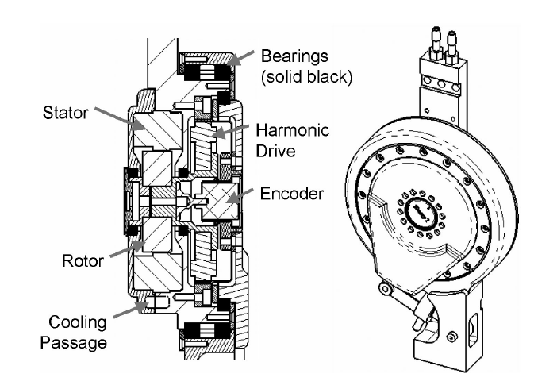

Figure.2.1 Electric actuator used in BLEEX

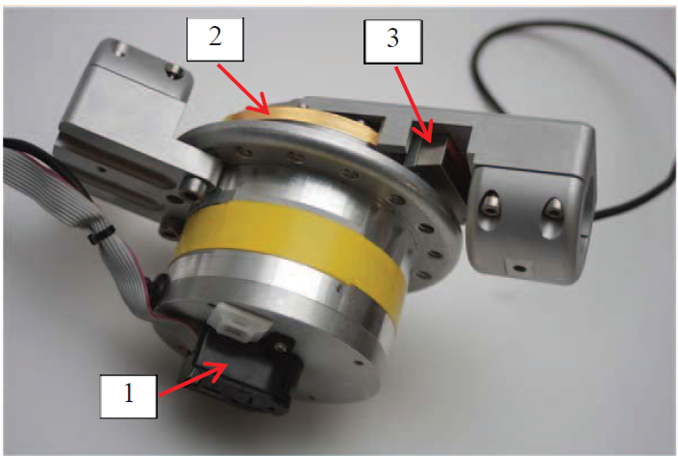

Figure.2.2 Actuators used in Mina exoskeleton

The block box (1) at the bottom of the picture is the encoder on the back shaft of the motor rotor. The gold strip (2) at the top of the picture, which is fixed to the base of the actuator, is the part of the output encoder. The read-head (3) of the output encoder is fixed to the output of the actuator. As the output moves, the read-head passes over the gold strip providing relative motion information. Series elastic actuators are also used in later version of NASA’s Mina exoskeleton [34]. While electric actuators can control force by controlling current, pneumatic and hydraulic systems can control force by controlling pressure. Series Elastic Actuators have low impedance and friction, and thus can achieve high quality force control. They therefore are well suited for robots in unstructured environments. In Series Elastic Actuators, stiff load cells (which are delicate, expensive, and induce chatter) are replaced with a significantly compliant elastic element (which is robust, inexpensive, and stable).

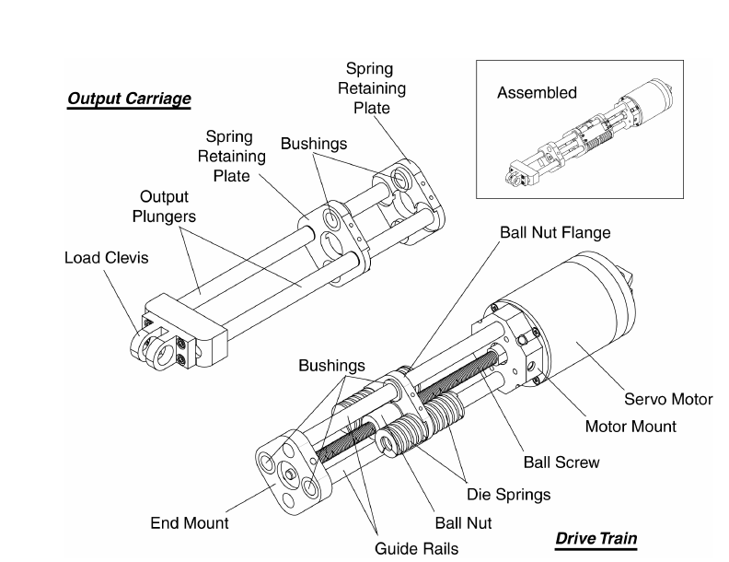

Figure.2.3 Elastic Actuator (version SEA23-23)

In Table 2.4 the Series Elastic Actuators are compared with traditional actuation methods. Series Elasticity improves the force fidelity of gear motors and hydraulics so they are comparable to direct drive motors without sacrificing high force/torque capabilities. They are lighter than direct drive motors in high force applications since they can use an optimal gear reduction. Position controllability remains good as a position servo can be implemented on top of the force control servo. Some bandwidth is lost in that process. However, we have found that the achievable position control bandwidth of Series Elastic Actuators is still higher than that of muscle.

|  |  |  |  |  |  |
| --- | --- | --- | --- | --- | --- |
| **Actuation type** | **Max.Force** | **Max.Speed** | **Low Force Ability** | **Position Controllability** | **Back-drivability** |
| Pneumatic | Med. | Med. | Fair, Stiction | Poor | Fair |
| Hydraulic | High | Med. | Fair, Stiction | Good | Poor |
| Direct drive Electric | Low | High | Excellent | Good | Excellent |
| Electric gear motor | Med./High | High | Poor, Friction | Good | Poor |
| Electric Series Elastic  Actuator | Med./High | High | Excellent | Good | Excellent |
| Hydraulic Series Elastic  Actuator | High | Med. | Excellent | Good | Excellent |

Table.2.4 Comparison of major actuation technologies

**2.4 Adjustable mechanism for Height:**

BLEEX uses linear hydraulic actuators for the proper joint adjustment at the shank and thigh parts. The main function of the BLEEX shank and thigh are to provide structural support and to connect the flexion/extension joints together. Both the shank and thigh are designed to adjust to fit 90% of the population; they consist of two pieces that slide within each other and then lock at the desired length.

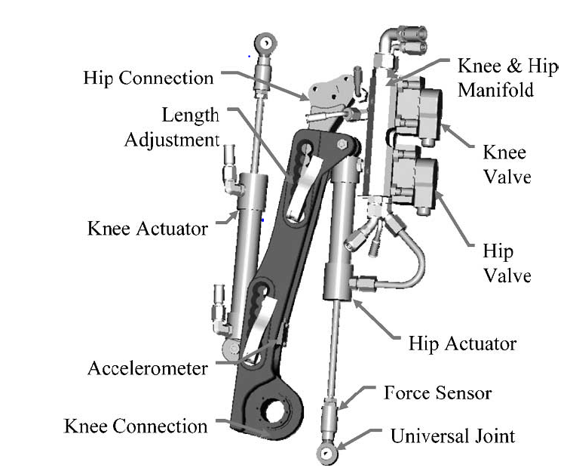

Figure.2.4. BLEEX thigh design

Other mechanism is compliant mechanism for the height adjustment [35]. The compliant mechanism is responsible for the joint compliance and its adjustment. A set of elastic elements is placed in a slider system that is connected to a spindle drive for adjusting the slider position along the compliant frame. A 20-W Maxon DC motor, RE-25, is connected to the spindle drive to exert the required force for varying the slider position on command. The linear guides along the frame are conceived to reduce the external forces transmitted to the spindle.

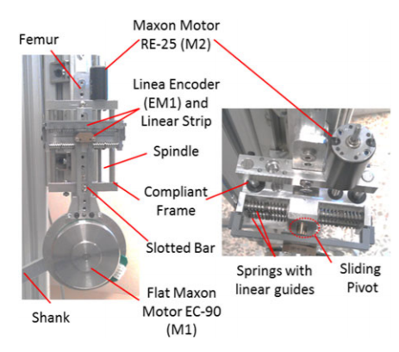

Figure.2.5 Coupling between the actuator components

**CHAPTER 3**

**GAIT ANALYSIS**

**3.1 Introduction to Gait Analysis:**

Gait analysis is the systematic study of animal locomotion, more specifically the study of human motion, using the eye and the brain of observers, augmented by instrumentation for measuring body movements, body mechanics, and the activity of the muscles [36]. Gait analysis is used to assess and treat individuals with conditions affecting their ability to walk. It is also commonly used in sports biomechanics to help athletes run more efficiently and to identify posture-related or movement-related problems in people with injuries.

**3.2 Process and Equipment:**

A typical gait analysis laboratory has several cameras (video or infrared) placed around a walkway or a treadmill, which are linked to a computer. The patient has markers located at various points of reference of the body (e.g., iliac spines of the pelvis, ankle malleolus, and the condyles of the knee), or groups of markers applied to half of the body segments. The patient walks down the catwalk or the treadmill and the computer calculates the trajectory of each marker in three dimensions. A model is applied to calculate the movement of the underlying bones. This gives a complete breakdown of the movement of each joint. One common method is to use Helen Hayes Hospital marker set, [37] in which a total of 15 markers are attached on the lower body. The 15 marker motions are analysed analytically, and it provides angular motion of each joint. To calculate the kinetics of gait patterns, most labs have floor-mounted load transducers, also known as force platforms, which measure the ground reaction forces and moments, including the magnitude, direction and location (called the centre of pressure).

The parameters taken into account for the gait analysis are as follows:

* Step length
* Stride length
* Cadence
* Speed
* Dynamic Base
* Progression Line
* Foot Angle
* Hip Angle

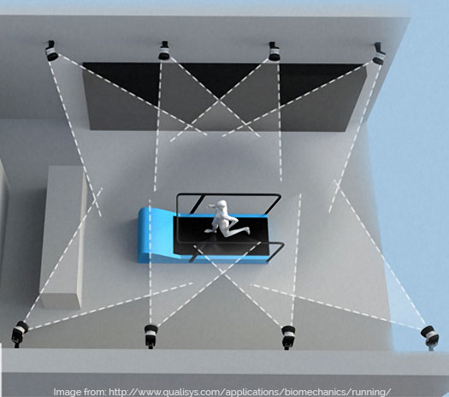

Figure 3.1. Human Gait Motion capture

**3.3 OpenSim software:**

OpenSim is a software package that enables us to build, exchange, and analyze computer models of the musculoskeletal system and dynamic simulations of movement. OpenSim software is used in a wide variety of applications, including biomechanics research, medical device design, orthopaedics and rehabilitation science, neuroscience research, ergonomic analysis and design, sports science, computer animation, robotics research, biology, and education. OpenSim includes a wide variety of features. Some of the most useful features include:

* Taking pictures of musculoskeletal models and making animated movies
* Plotting results of your analysis
* Scaling the size of a musculoskeletal model: Scaling
* Performing inverse kinematics analyses to calculate joint angles from marker positions
* Performing inverse dynamics analyses to calculate joint moments from joint angles and external forces
* Generating forward dynamics simulations of movement: Forward Dynamics
* Analyzing dynamic simulations

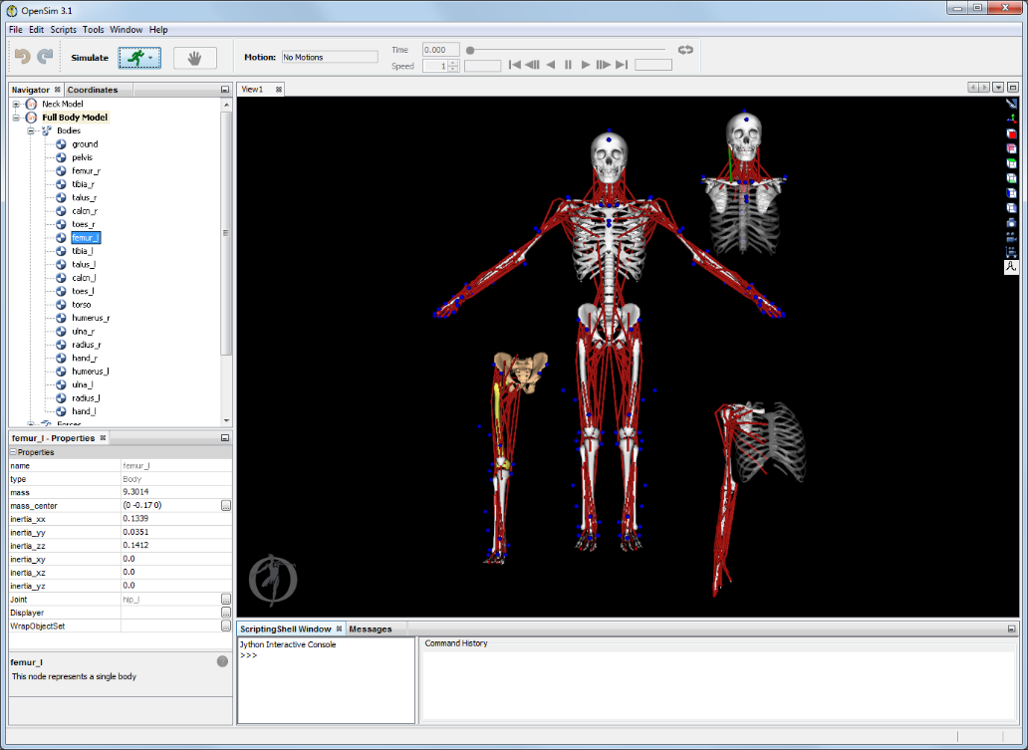

Figure 3.2. OpenSim software User Interface

**3.4 OpenSim Workflow:**

OpenSim has a broad range of capabilities for generating and analyzing musculoskeletal models and dynamic simulations. The first component of any analysis is an OpenSim model. An OpenSim model represents the dynamics of a system of rigid bodies and joints that are acted upon by forces to produce motion. The OpenSim model file is made up of components corresponding to parts of the physical system. These parts include bodies, joints, forces, constraints, and controllers.

**3.4.1 Importing Experimental Data:**

In many cases, one will use OpenSim to analyze experimental data that has collected in the laboratory. This data typically includes:

* Marker trajectories or joint angles from motion capture
* Force data, typically ground reaction forces and moments and/or centers of pressure
* Electromyography

OpenSim simulations are generated from human motion and forces that are experimentally collected and used as inputs to Inverse Kinematics, Inverse Dynamics, Static Optimization, and Computed Muscle Control algorithms. As for any model and algorithm, the quality of the input data is essential for high-quality results. Typically collected motion data, markers and forces, should be collected with familiarity on how these would be used to generate simulations.

**3.4.2 The Inverse Problem:**

OpenSim enables researchers to solve the Inverse Dynamics problem, using experimental measured subject motion and forces to generate the kinematics and kinetics of a musculoskeletal model (see figure 3.3).

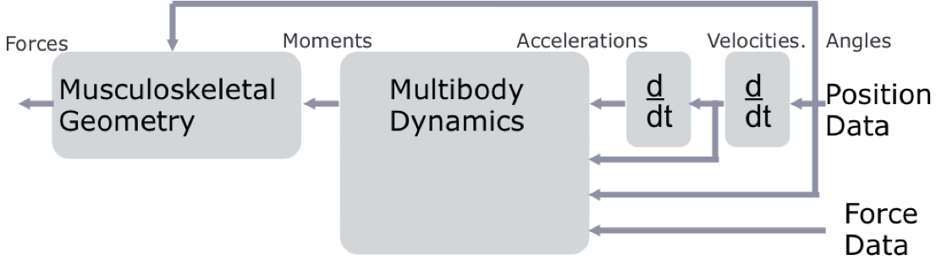

Figure 3.3. Solving flow of Inverse problem

In inverse dynamics, experimentally measured marker trajectories and force data are used to estimate a model’s kinematics and kinetics.

**3.4.3 Scaling:**

If a model from the existing library of models are used, the next step is to scale the model to match the experimental data collected for the subject functionality provided by the Scale Tool in OpenSim. The purpose of scaling a generic musculoskeletal model is to modify the anthropometry, or physical dimensions, of the generic model so that it matches the anthropometry of a particular subject. Scaling is one of the most important steps in solving inverse kinematics and inverse dynamics problems because these solutions are sensitive to the accuracy of the scaling step. In OpenSim, the scaling step adjusts both the mass properties (mass and inertia tensor), as well as the dimensions of the body segments.

**3.4.4 Inverse Kinematics:**

The Inverse Kinematics (IK) Tool in OpenSim finds values for the generalized coordinates (joint angles and positions) in the model that best match the experimental kinematics recorded for a particular subject (see figure 3.4). The experimental kinematics targeted by IK can include experimental marker positions, as well as experimental generalized coordinate values (joint angles). The IK Tool goes through each time step of motion and computes generalized coordinate values which position the model in a pose that "best matches" experimental marker and coordinate values for that time step. Mathematically, the "best match" is expressed as a weighted least-squares problem, whose solution aims to minimize both marker and coordinate errors. Experimental markers are matched by model markers throughout the motion by varying the generalized coordinates (e.g., joint angles) through time.

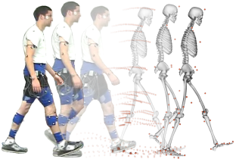

Figure 3.4. Experimental values and model values matching

**3.4.5 Inverse Dynamics:**

Dynamics is the study of motion and the forces and moments that produce that motion. The Inverse Dynamics (ID) Tool determines the generalized forces (e.g., net forces and torques) that cause a particular motion, and its results can be used to infer how muscles are actuated to generate that motion. To determine these internal forces and moments, the equations of motion for the system are solved with external forces (e.g., ground reaction forces) and accelerations given (estimated by differentiating angles and positions twice). The equations of motion are automatically formulated using the kinematic description and mass properties of a musculoskeletal model in Simbody™.



Figure 3.5. Inverse dynamic Tool function

The subject01_Setup_InverseDynamics.xml file is the setup file for the Inverse Dynamics Tool.

Input:

* subject01_walk1_ik.mot: Motion file containing the time histories of generalized coordinates that describe the movement of the model.
* subject01_walk1_grf.xml: External load data (i.e., ground reaction forces, moments, and centre of pressure location).
* subject01_simbody.osim: A subject-specific OpenSim model generated by scaling a generic model with the Scale Tool or by other means, along with an associated marker set containing adjusted virtual markers.

Output:

subject01_walk1_InverseDynamics_force.sto: Storage file containing the time histories of the net joint torques and forces acting along the coordinate axes that produce the accelerations estimated (via double differentiation) from the measured experimental motion and the external forces applied.

**3.5 Gait dataset collection and Analysis:**

The experimental gait data that was considered for the analysis was collected by Jill Higginson and Chand John in the Neuromuscular Biomechanics Lab at the University of Delaware [38]. The data consists of marker trajectories and ground reaction forces for an unimpaired adult male of height 1.83m weighing 72.6 kg walking on an instrumented split-belt treadmill at a velocity of 1.36 m/s. The motion data collected with the help of marker trajectories are used to compute the Joint angles using the Inverse Kinematics toolbox of OpenSim software. The Net Joint moments are computed by using the joint angles and ground reaction forces using the Inverse Dynamics toolbox of OpenSim software. The net Joint moments obtained for the above subject after solving the inverse dynamics problem is shown in the Figure 3.6, Figure 3.7, Figure 3.8 for Hip, Knee, and Ankle Joints respectively.

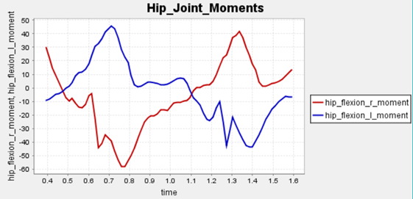

Figure 3.6. Hip Joints Moments

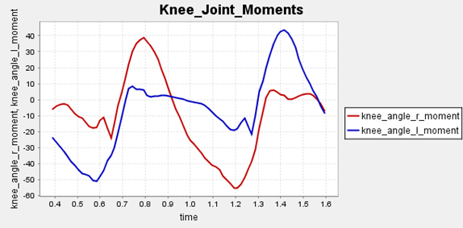

Figure 3.7. Knee Joint Moments

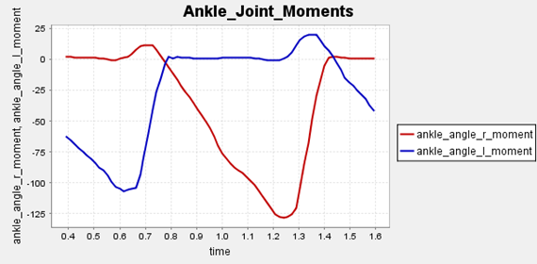

Figure 3.8. Ankle Joint Moments

From the plots, the Joint moments of Hip, Knee and Ankle joints can be found out which is varying depending on the postures at different point during the stance to swing phase. It is observed that for the same subject waking, there is difference in peak Joint moments between left and right leg which is due to the modelling and marker data processing error which is common due to the change in centre of mass during the motion capture. Based on the above plots the torques are considered to be ranging between 30 to 55 Nm. According to [39], it was empirically found that at the hip joint an average torque of 35 Nm is adequate for a normal person. So a torque of 35 Nm was considered for the exoskeleton design [40]. The data collected are not representatives of elderly who require assistance. However, the data was considered for finding the torques required to create by the actuators during walking.

**CHAPTER 4**

**DESIGN OF EXOSKELETON**

**4.1 Design considerations:**

The major design requirements were: (1) Wearability, (2) Light weight, (3) Adaptability to different users and (4) Safety.

(1) Wearability: Since the user has to support the device, wearability is very important. To improve wearability, the motor installation strategy to the lower limb has to be considered. If motors are mounted in unreasonable places, the exoskeleton may affect the walking pattern of wearer. So, mounting of motor should be perfect.

(2) Light weight: It is necessary to minimize the weight of an exoskeleton device to minimize power consumption and maximize patient comfort. To decrease the weight of the device, the main frames of the device are to be made of less weight and high strength materials. The total weight of the system should be light and comfortable to the wearer.

(3) Adaptability to different users: To ensure that most of the users’ limbs are properly aligned with the exoskeleton, some adjustable mechanisms have to be designed. The height and waist of the exoskeleton has to be adjustable and it should be in wearer comfort.

(4) Safety: As the system is in direct contact with the human, safety is very important for an assistive device. It is better to consider a safety program to detect the force between the hip, thigh and waist.

The anthropometric data of the wearer considered for the design of the exoskeleton is shown in the Table.4.1.

|  |  |
| --- | --- |
| **Parameters** | **Range** |
| Weight(kg) | 100 |
| Height(cm) | 153.2-187.8 |
| Waist circumference(cm) | 80-110 |
| Walking speed(m/s) | 1.09-1.24 |

Table 4.1. Anthropometric data

**4.2 Material:**

Aluminium 7075 is the strongest material among the aluminium alloys. Particularly, aluminium 7075 is hard with good mechanical properties often used in high-stress structures requiring high strength and corrosion resistance. So, Aluminium 7075 T6 was chosen as the primary material for the structural design of Hip, Thigh, knee, Ankle and foot frames considering its high Yield strength and less density making it strong and lightweight material for the Exoskeleton. There are other metals and composites like magnesium, titanium and carbon fibre which are lighter and stronger than aluminium alloy. But, by considering the cost factor and to make the end product more affordable, aluminium alloy is selected for the design of exoskeleton.

**4.3 Components:**

From literature survey it is found that the required torque to move human with the help of exoskeleton is ranging between 35 to 180 Nm. Due to the complex nature of exoskeleton design, common mechanical effects such as friction and backlash represent significant design challenges. To reduce these terms motors and gear drives are used.

**4.3.1 Motors:**

The harmonious coordination of force and position between patient and exoskeleton is difficult between different subjects [41]. The literature suggests that the use of electric motors provide a reduction in power consumption during gait [42]. DC motors meet the criteria of necessary power with a compact and portable solution for wearable devices. Based on that, brushless DC motors coupled to a type Harmonic Drive gearbox were selected. A 100 W motor (Maxon, EC60 Flat Brushless) is used in the hip, knee and ankle joints. This motor has a rated voltage of 24 VDC and nominal torque of 220 mNm.

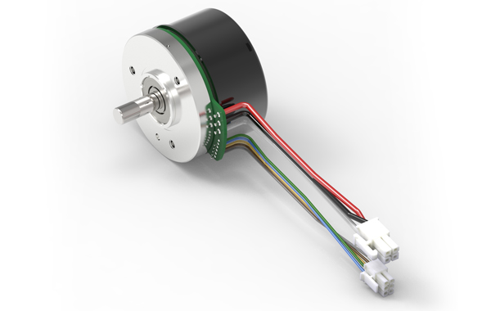

Figure.4.1. Maxon EC60 Flat Brushless motor

|  |  |
| --- | --- |
| **Parameter** | **Units** |
| Nominal voltage | 24 V |
| No load speed | 4300 rpm |
| Nominal speed | 3730 rpm |
| Nominal torque | 269 mNm |
| Stall torque | 4300 mNm |
| Bearing type | ball bearings |
| Weight | 370 g |

Table.4.2 Maxon Motor specifications

**4.3.2 Harmonic Gear Drive:**

To obtain high gear ratio and zero backlash harmonic gear drives are used for exoskeleton. The flex spline is shaped like a shallow cup. The sides of the spline are very thin, but the strain wave gearing theory is based on elastic dynamics and utilizes the flexibility of metal. The mechanism has three basic components: a wave generator, a flex spline, and a circular spline as shown in figure.4.2. The wave generator is made up of two separate parts: an elliptical disk called a wave generator plug and an outer ball bearing. The gear plug is inserted into the bearing, giving the bearing an elliptical shape. The bottom is relatively rigid. This results in significant flexibility of the walls at the open end due to the thin wall, and in the closed side being quite rigid and able to be tightly secured. Teeth are positioned radially around the outside of the flex spline. The flex spline fits tightly over the wave generator, so that when the wave generator plug is rotated, the flex spline deforms to the shape of a rotating ellipse and does not slip over the outer elliptical ring of the ball bearing. The ball bearing lets the flex spline rotate independently to the wave generator's shaft. The circular spline is a rigid circular ring with teeth on the inside. The flex spline and wave generator are placed inside the circular spline, meshing the teeth of the flex spline and the circular spline. Because the flex spline is deformed into an elliptical shape, its teeth only actually mesh with the teeth of the circular spline in two regions on opposite sides of the flex spline. a gearbox (Harmonic Drive, CSD-20-160-2AGR) is coupled to the motor shaft in order to reduce speed and increase torque. Harmonic Drive gearboxeswere selected to reduce the weight and size of the final actuators. A gear ratio of 160:1 gives to each joint a continuous net torque of 35 Nm and peak torques of 180 Nm.

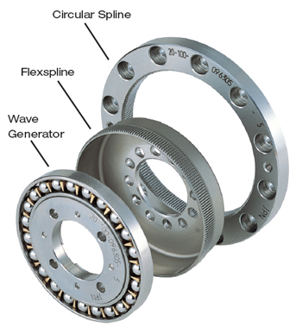

Figure.4.2 Harmonic Gear drive

**4.4 CAD Model:**

To meet above design requirements and parameters CAD model was designed in SOLIDWORKS 2018 as shown in figure.4.3.

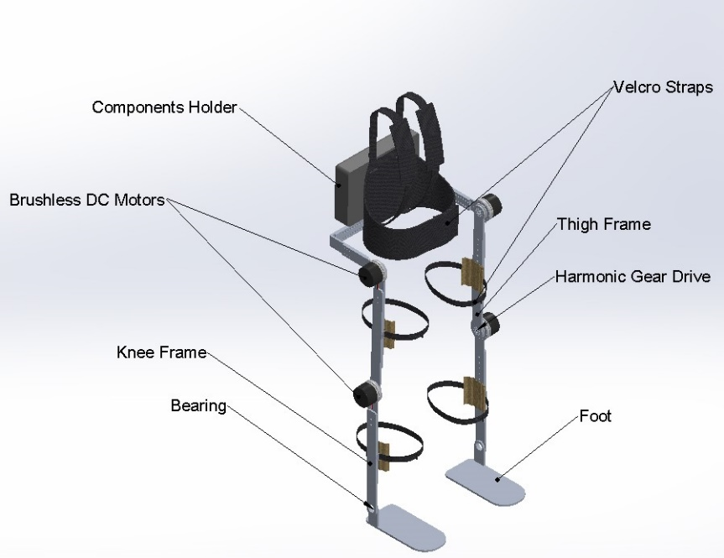

Figure.4.3 Full exoskeleton designed in solidworks

This exoskeleton was designed for assistance of elderly people with a height between 137 cm to 158 cm and the waist circumference ranging between 80cm to 110 cm. The desired height and waist sizes can be adjusted by the wearer with the help of nut and bolt fastener adjustment provided at the Hip and Thigh frames as shown in figure.4.4.

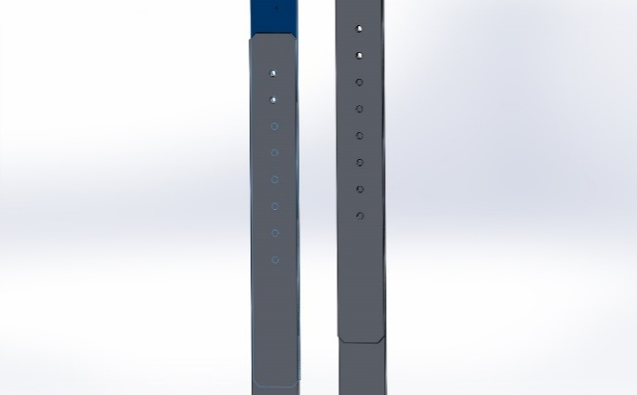

Figure.4.4 Height adjustment

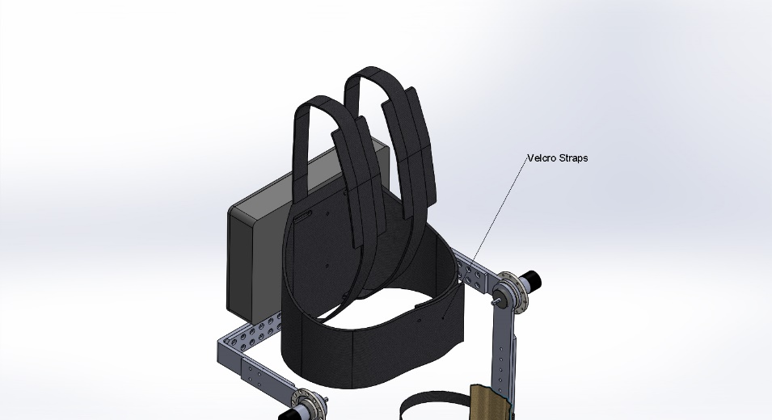

Figure.4.5 Velcro straps

On considering the weight, design complexity and cost factors nut and bolt fasteners are used to keep the design simple and light weighted which is even cost effective. Velcro straps are provided making the design compact and comfortable for the wearer by taking ergonomics into consideration. The battery pack and micro-controller unit are placed inside a back casing provided on the posterior side of the hip for proper stability and support to the spine, see Figure. By taking the Weight range data from the previous section i.e. 64 to 94 kg the exoskeleton is expected to carry a safe load of 100kg.

**4.5 Cost estimation:**

The cost estimation for this project based on the selected components and material is shown in the table below.

|  |  |  |  |  |
| --- | --- | --- | --- | --- |
| **S.no** | **Components** | **Cost** | **Quantity** | **Total Cost** |
| **1.** | **Motors** | 18000 | 4 | 72,000 |
| **2.** | **Gear Drive** | 40,000 | 4 | 160,000 |
| **3.** | **Material** | 800/kg | 3 | 2400 |
| **4.** | **Battery(Li-Po)** | 3000 | 1 | 3000 |
| **5.** | **Machining** | 2600 |  | 2600 |
|  | **TOTAL** |  |  | 2,40,000 |

Table.4.3 Cost estimation of Exoskeleton

**CHAPTER 5**

**ANALYSIS OF EXOSKELETON**

**5.1 Finite element analysis:**

The Finite Element Analysis (FEA) is the simulation of any given physical phenomenon using the numerical technique called Finite Element Method (FEM). Engineers use it to reduce the number of physical prototypes and experiments and optimize components in their design phase to develop better products, faster. It is necessary to use mathematics to comprehensively understand and quantify any physical phenomena such as structural or fluid behaviour, thermal transport, wave propagation, the growth of biological cells, etc. Most of these processes are described using Partial Differential Equations (PDEs). However, for a computer to solve these PDEs, numerical techniques have been developed over the last few decades and one of the prominent ones, today, is the Finite Element Analysis. Differential equations can not only describe processes of nature but also physical phenomena encountered in engineering mechanics. These partial differential equations (PDEs) are complicated equations that need to be solved in order to compute relevant quantities of a structure (like stresses (ϵϵ), strains (ϵϵ), etc.) in order to estimate a certain behaviour of the investigated component under a given load. It is important to know that FEA only gives an approximate solution of the problem and is a numerical approach to get the real result of these partial differential equations. Simplified, FEA is a numerical method used for the prediction of how a part or assembly behaves under given conditions. It is used as the basis for modern simulation software and helps engineers to find weak spots, areas of tension, etc. in their designs. The results of a simulation based on the FEA method are usually depicted via a colour scale. For example, as shown in fig.5.1.

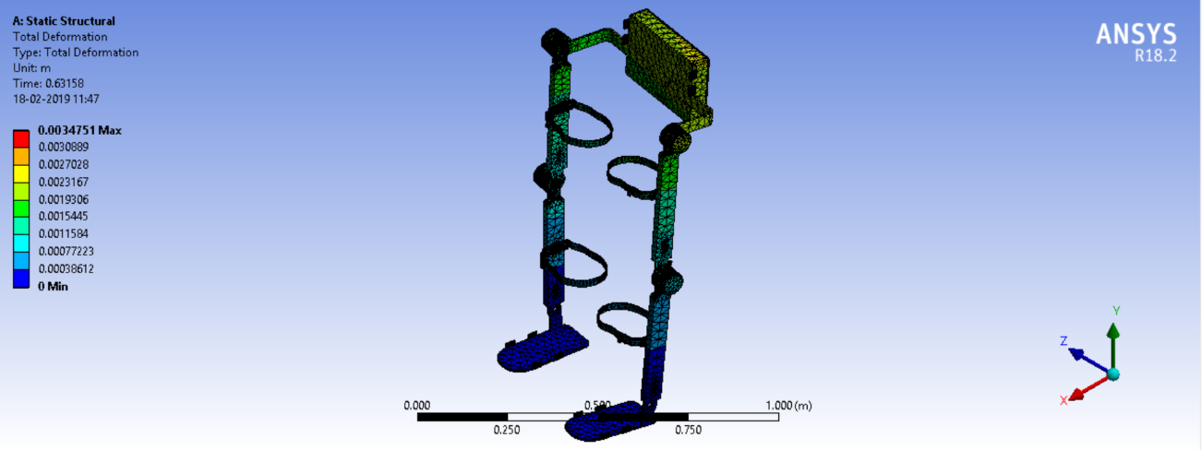

Figure.5.1

**5.1.1 Structural analysis:**

Structural analysis is the determination of the effects of loads on physical structures and their components. Structures subject to this type of analysis include all that must withstand loads, such as buildings, bridges, vehicles, furniture, attire, soil strata, prostheses and biological tissue. Structural analysis employs the fields of applied mechanics, materials science and compute a structure’s deformations, internal forces, stresses, support reactions, accelerations, and stability. The results of the analysis are used to verify a structure's fitness for use, often precluding physical tests. Structural analysis is thus a key part of the engineering design of structures.

**5.1.2 Static structural analysis:**

A static structural analysis determines the displacements, stresses, strains, and forces in structures or components caused by loads that do not induce significant inertia and damping effects. Steady loading and response conditions are assumed; that is, the loads and the structure's response are assumed to vary slowly with respect to time. A static structural load can be performed using the ANSYS, Samcef, or ABAQUS solver. The types of loading that can be applied in a static analysis include:

* Externally applied forces and pressures
* Steady-state inertial forces (such as gravity or rotational velocity)
* Imposed (nonzero) displacements
* Temperatures (for thermal strain)

**5.1.3 Modal analysis:**

The goal of modal analysis in structural mechanics is to determine the natural mode shapes and frequencies of an object or structure during free vibration. It is common to use the finite element method (FEM) to perform this analysis because, like other calculations using the FEM, the object being analyzed can have arbitrary shape and the results of the calculations are acceptable. The types of equations which arise from modal analysis are those seen in Eigen systems. The physical interpretation of the Eigenvalues and eigenvectors which come from solving the system are that they represent the frequencies and corresponding mode shapes. Sometimes, the only desired modes are the lowest frequencies because they can be the most prominent modes at which the object will vibrate, dominating all the higher frequency modes. It is also possible to test a physical object to determine its natural frequencies and mode shapes. This is called an Experimental Modal Analysis. The results of the physical test can be used to calibrate a finite element model to determine if the underlying assumptions made were correct (for example, correct material properties and boundary conditions were used).

**5.2 Static structural Analysis on designed Exoskeleton:**

**A. FULL EXOSKELTON:** The Exoskeleton model was designed in SolidWorks and was imported to the Ansys Workbench in STEP file format for the Static Structural Analysis using Finite Element Method. The parts like motors, Velcro straps, and component holder are removed during the analysis to reduce the problem solving time. These removed components make the problem overly defined and will not bring huge variation in the solution. Aluminium 7075 T6 is used as the material for the Hip, Knee, Ankle and Foot frames. 15-5 ph Stainless-steel is used as the material for the circular-spline of the Harmonic drive and Nitronic 60 stainless-steel for the Flex-spline of the Harmonic drive. The material properties for the Aluminium 7075 T6, Nitronic-60 Stainless steel,15-5 ph Stainless steel that is defined in the Ansys workbench is given in the Table.5.1.

|  |  |  |  |
| --- | --- | --- | --- |
| **Property** | **Aluminium 7075** | **Nitronic-60 stainless-steel** | **15-5 ph Stainless-steel** |
| Density(g/cc) | 2.81 | 7.58 | 8.01 |
| Yield strength (MPa) | 503 | 655 | 1070 |
| Young’s Modulus (GPa) | 71.7 | 179.2 | 200 |
| Poisson’s Ratio | 0.33 | 0.28 | 0.29 |
| Ultimate strength(MPa) | 572 | 758.42 | 1110 |

Table.5.1 Material properties

Meshing is done by selecting size function as Adaptive with Relevance value 40 in Ansys work bench. The analysis is done to check whether the structure is going to withstand a weight of 100 kg, so a force of 981N is applied on the Hip frame and the Left and Right are made as Fixed Support [43]. A moment of 35 Nm in positive z-direction is applied on the flex spine of the Harmonic drive at both Knee joints. A moment of 35 Nm in negative z-direction is applied on the flex spline of the Harmonic drive at both Hip joints. This is because the Harmonic drive is going to produce a maximum output torque of 35 Nm at the Hip and Knee joints. Standard Earth Gravity is also added to the design during the analysis. The design setup along with the Forces and moments in Ansys Workbench is shown in the Figure.5.2.

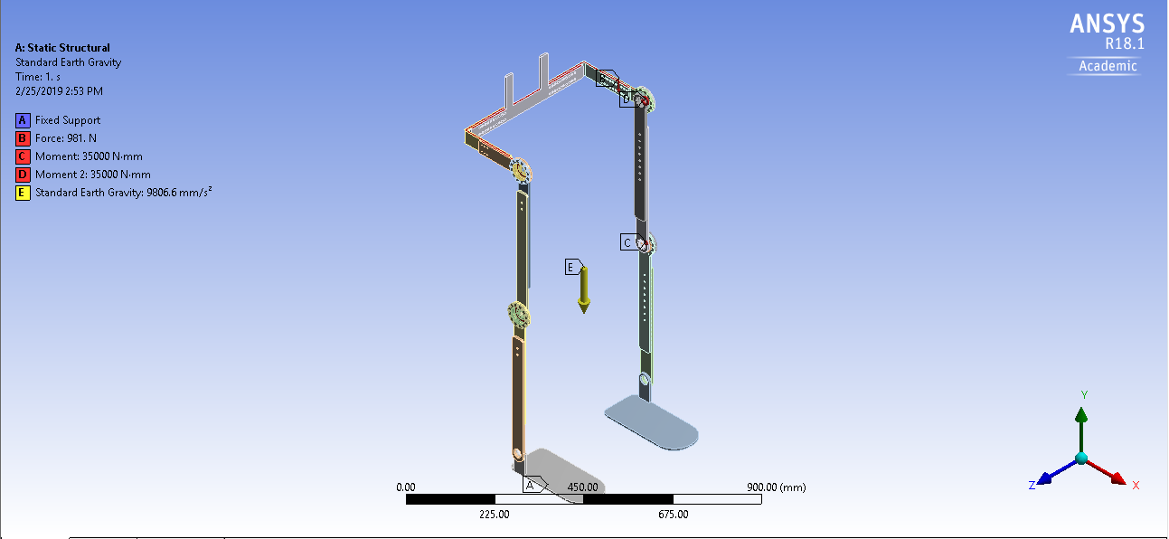

Figure.5.2 Exoskeleton Analysis boundary conditions

The solution for the Total Deformation and the Von-Missies stress is evaluated by solving the problem. A maximum deformation of 0.44mm is obtained as shown in the Figure5.3. The maximum stress of 382.15 MPa is acting on the flex spline which is less than the Yield strength of the 15-5 ph stainless-steel which is 1070 MPa, see Figure.5.4. The place where the Maximum and Minimum stress are acting as shown figure.5.5. So the design is structurally strong and stable for a person of 100kg weight.

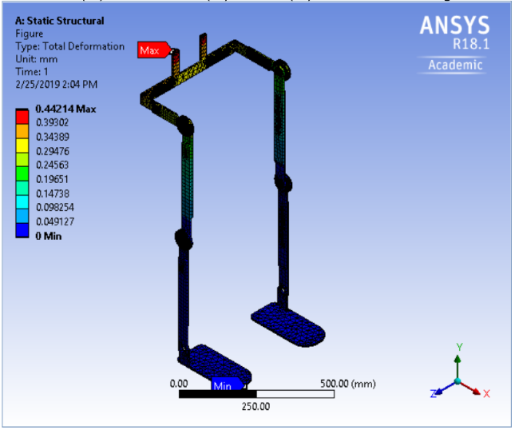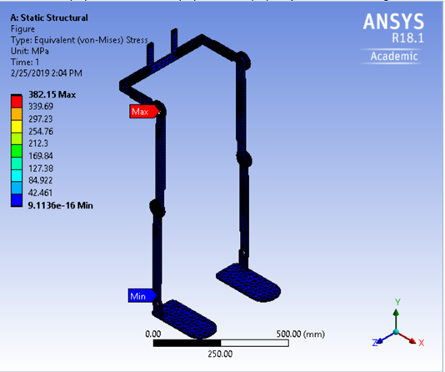

Figure.5.3 Total deformationFigure.5.4 Equivalent stress

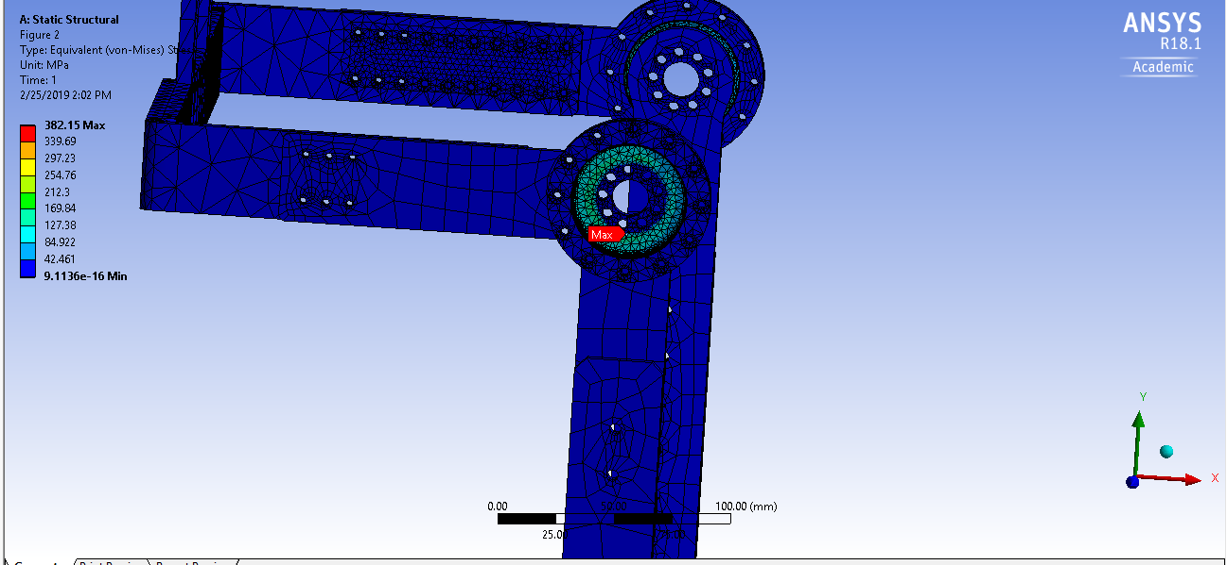

Figure.5.5 Max Stress acting Area

**B. HIP FRAME:** The Hip frame alone is imported into the Ansys workbench in STEP file format for Static Structural Analysis using Finite Element Method. Aluminum 7075 T6 is defined as the material for the Hip frame and a Force of 981N (100 kg weight) is applied on the Hip. The two ends of the Hip Frame are made as Fixed Supports. Standard gravitational Force is also added to the Hip frame during the Analysis. The design setup of the Hip frame along with the Forces and Fixed Supports in Ansys workbench before the analysis is shown in the Figure.5.6. This Analysis is being done to find the Total deformation of the Hip frame if a weight of 100 kg is acting on it during the fixed end condition. The Maximum stress acting on the frame during these conditions can also be analyzed with respect to the Aluminum 7075 T6 properties.

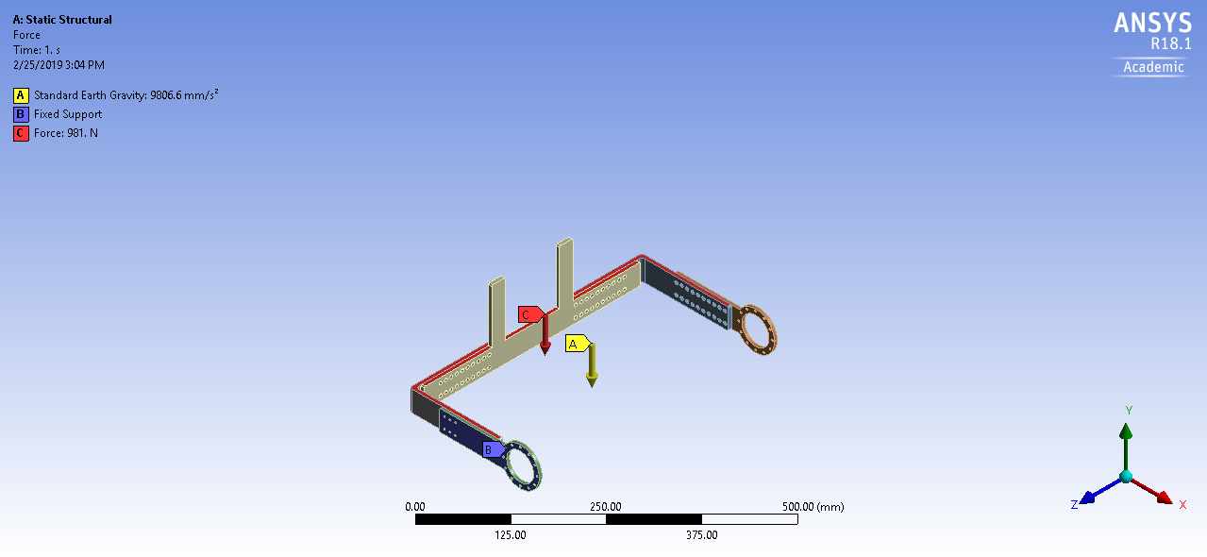

Figure.5.6 Hip Analysis Boundary conditions

Solution for Total Deformation and Von-Misses stress is evaluated by solving the problem in Ansys Workbench. The max deformation of the Hip frame is 0.23 mm under these loading conditions. The area where the maximum deformation is obtained is shown in the Figure. The maximum stress acting on the Hip frame structure is 27.12 MPa which is less than the Yield strength of Aluminum 7075 T6 i.e. 503 MPa. So the Hip frame is strong enough to withstand a load of 100kg. The area where the maximum stress is acting is shown in the Figure.5.8.

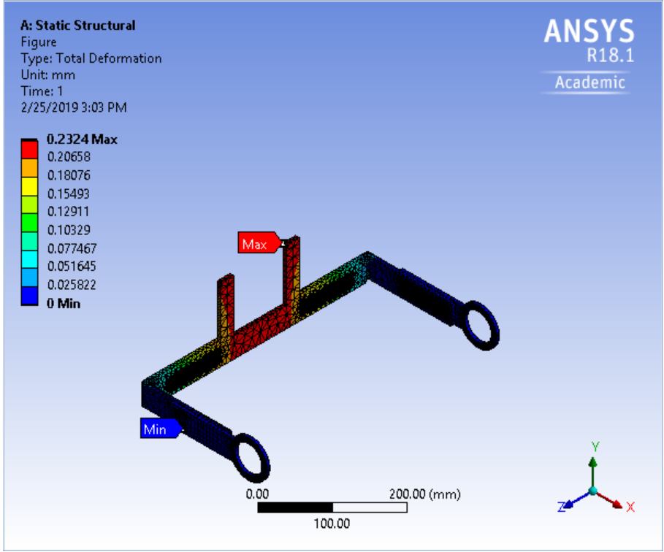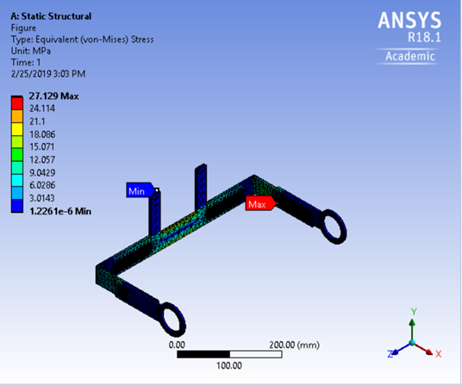

Figure.5.7 Total deformationFigure.5.8 Equivalent stress

|  |  |  |  |  |
| --- | --- | --- | --- | --- |
| **Structure** | **Max.Deformation**  **(mm)** | **Max.Stress**  **(MPa)** | **Min.Stress**  **(MPa)** | **Yield strength**  **(MPa)** |
| Full Exoskeleton | 0.44 | 382.15 | 9.11e-16 | 1070 |
| HIP Frame | 0.23 | 27.12 | 1.22e-6 | 503 |

Table.5.2 Ansys Workbench Result

**5.2.1 Maximum load capacity of the Exoskeleton:**

The maximum load the exoskeleton can withstand is found by solving the equivalent stress problem in Ansys workbench by gradually increasing the load on the Hip frame of the exoskeleton, see Table.5.3.

|  |  |  |
| --- | --- | --- |
| **Force on Exoskeleton(N)** | **Max.Deformtion(mm)** | **Max.Stress(MPa)** |
| 1200 | 0.59 | 411.95 |
| 1500 | 0.63 | 514.16 |
| 2400 | 1.014 | 820.78 |
| 3000 | 1.26 | 1025.2 |

Table.5.3 Deformation with respect to loading

Maximum stress of 1025.2 MPa is acting on the flex spline of the exoskeleton when a load of 305 kg is acting on the hip frame. The yield strength of the 15-5 ph stainless-steel is 1070 MPa and if the weight more than 305 kg is added the stress will go beyond the yield strength and the structure will fail.

**5.3 Modal Analysis on Exoskeleton:**

The static structural Analysis of the Exoskeleton in the previsions section showed that the Exoskeleton is safe during the static conditions. The Exoskeleton is not static and contains moving parts and motors. The exoskeleton is not going to be constrained to the laboratory conditions, in the real time the exoskeleton has to deal with uneven ground surfaces and elevation walking which involves lot of external vibrations acting on it. So, it is always a good engineering practice to study the dynamic characteristics of the structure during the product development phase [44]. The Modal analysis is done to find the natural frequency vibrations of the structure and Mode shapes during different order of vibrations.

**5.3.1 Analysis Methodology**:

The Exoskeleton model designed in the SolidWorks is imported into Ansys Workbench in STEP file format. The components like motors and components holder are removed to save the problem solving time and not to overly define the problem. Aluminum 7075 T6 is assigned as the material for the structural frames of the exoskeleton and Nitronic-60 Stainless-steel, 15-5 Ph Stainless-steel is assigned as the material for the circular spline and the Flex spline of the Harmonic drive respectively. Software controlled Adaptive mesh is selected for the meshing of the exoskeleton and the sizing factor is set to medium in Ansys workbench. The left and right foot frames are made as fixed support and the modal analysis problem is solved.

**5.3.2 Modal Analysis results**:

The first six modes of Natural frequency vibrations values are shown in the table (). The deformation of the exoskeleton with respect to the order of vibration under no external force condition is shown in the figures.5.9.

|  |  |  |
| --- | --- | --- |
| **Mode** | **Frequency(HZ)** | **MAX. Deformation(m)** |
| First order | 21.823 | 0.867 |
| Second order | 84.92 | 1.957 |
| Third order | 146.37 | 1.135 |
| Fourth order | 160.34 | 1.591 |
| Fifth order | 218.91 | 1.140 |
| Sixth order | 286.6 | 1.763 |

Table.5.4 Modal analysis frequency and vibration comparison

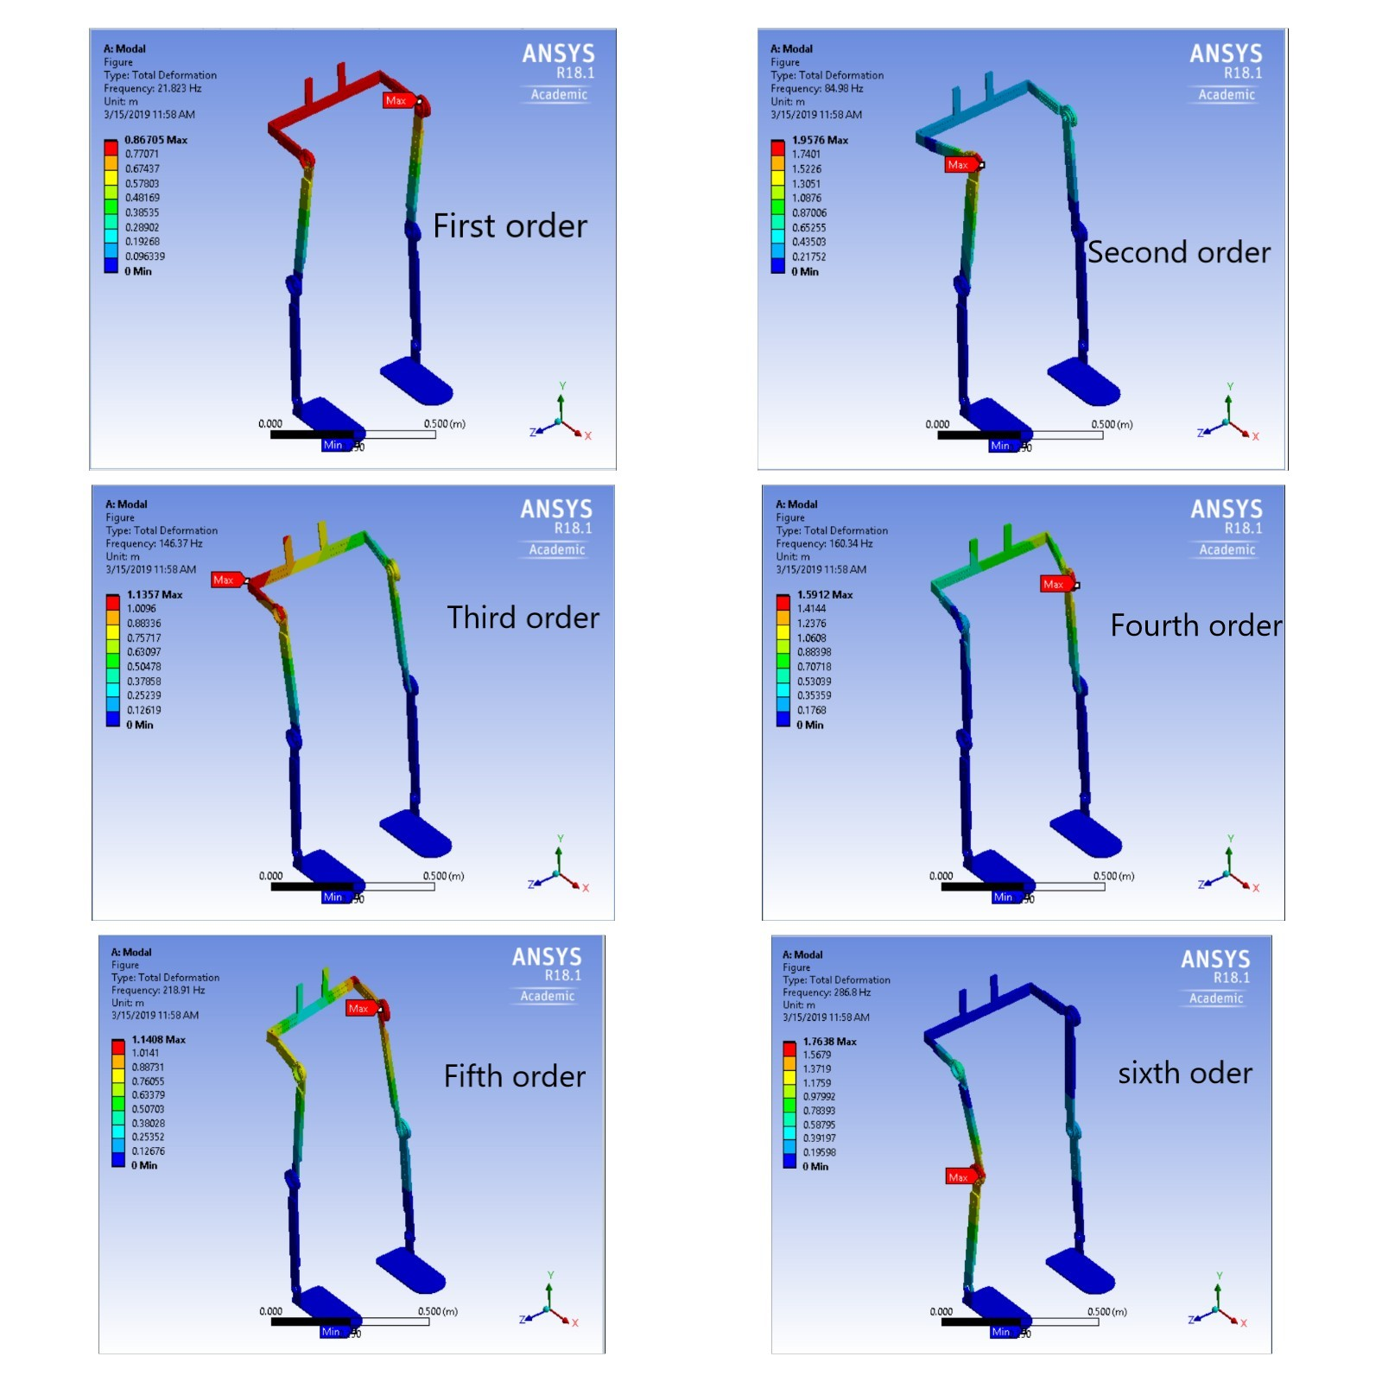

Figure.5.9 Modal analysis

From the results it is found that if an external force creates vibrations on the exoskeleton at the range of natural frequency vibrations values of the modal analysis, resonance will occur. The resonance will damage the strength of the exoskeleton. The motor selected for this exoskeleton has a nominal speed of 3840 rpm which creates a forced vibrational frequency of 64 Hz on the structure. From the above modal analysis results it is found that the natural frequency of the exoskeleton is not in the range of 64 Hz which means the motor won’t create resonance. Likewise, the dynamic characteristics of the exoskeleton during the walking on rough terrains can be depicted from the above natural frequency vibrations range of values.

**CHAPTER 6**

**FABRICATION OF EXOSKELETON**

**6.1 Fabricated design of Exoskeleton:**

A proper control system for the exoskeleton can only be obtained after a series of test iterations in real time. So a test exoskeleton is fabricated in order to perform different control algorithms on it. To achieve this, rather than fabricating a fully developed exoskeleton, a stripped down version of exoskeleton is fabricated by adding only the required components for the testing. The considerations of the test exoskeleton and the SolidWorks model is designed, see figure.6.1. This fabricated exoskeleton is not designed to carry the weight of a person; it is designed only for experimental purposes. The drafts of the individual component of the exoskeleton is given below:

***Hip frames:***

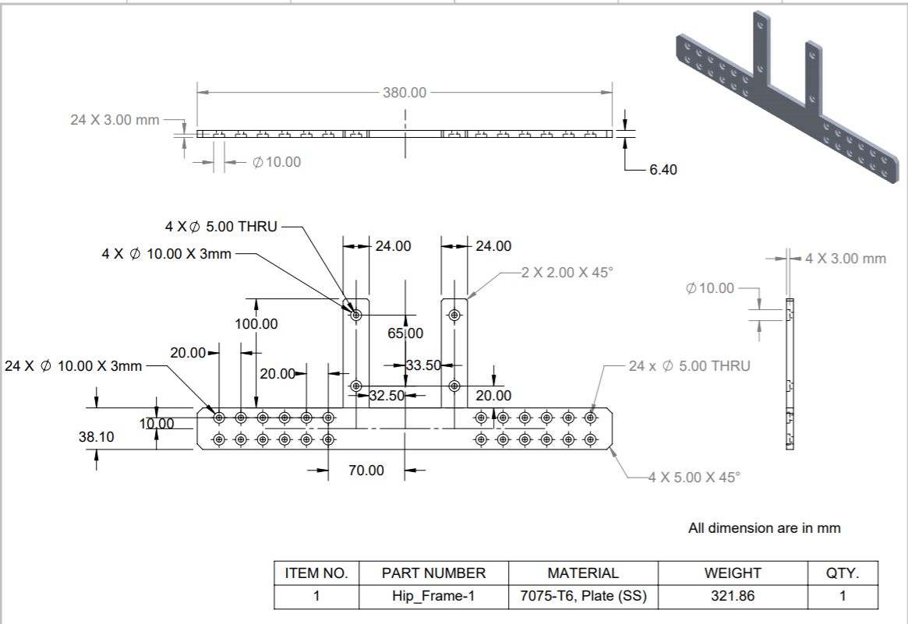

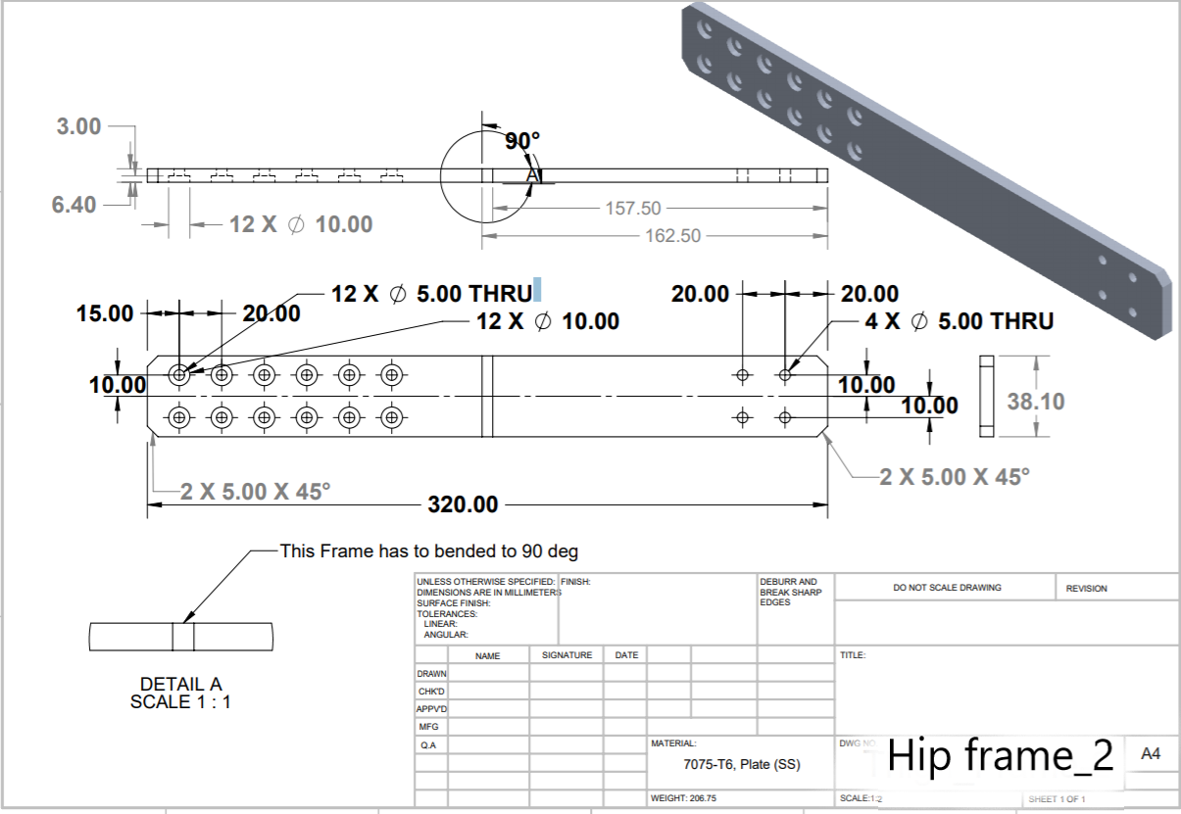

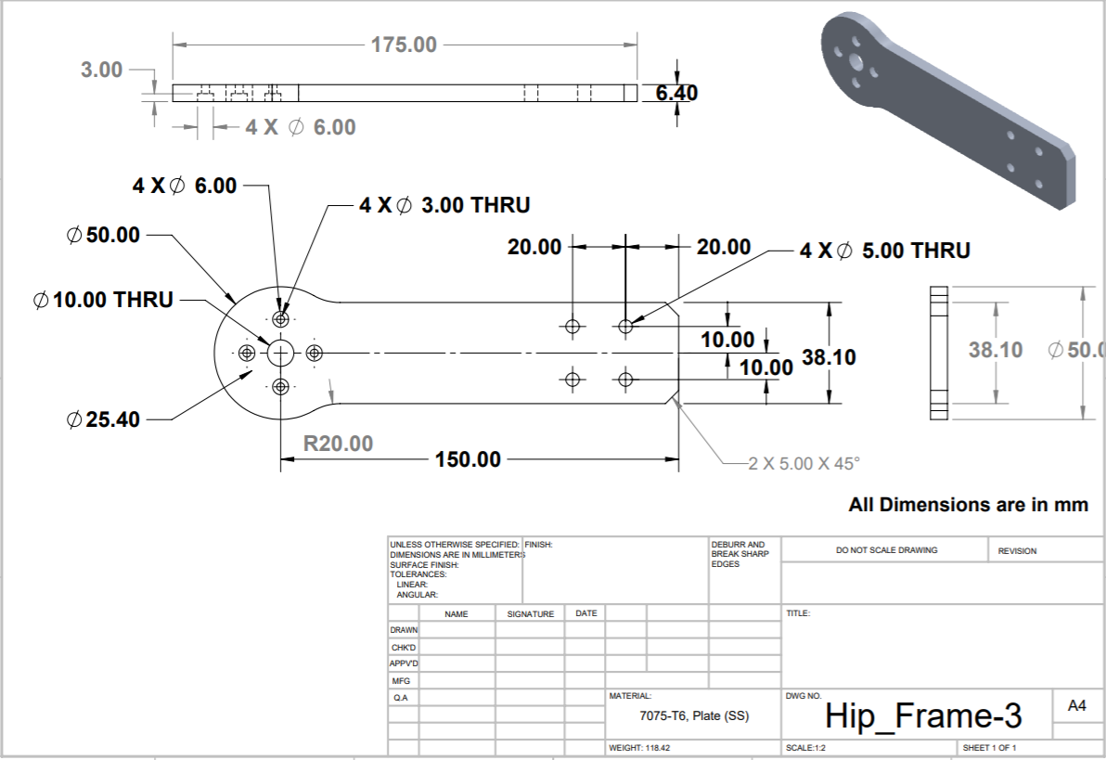

***Thigh frames:***

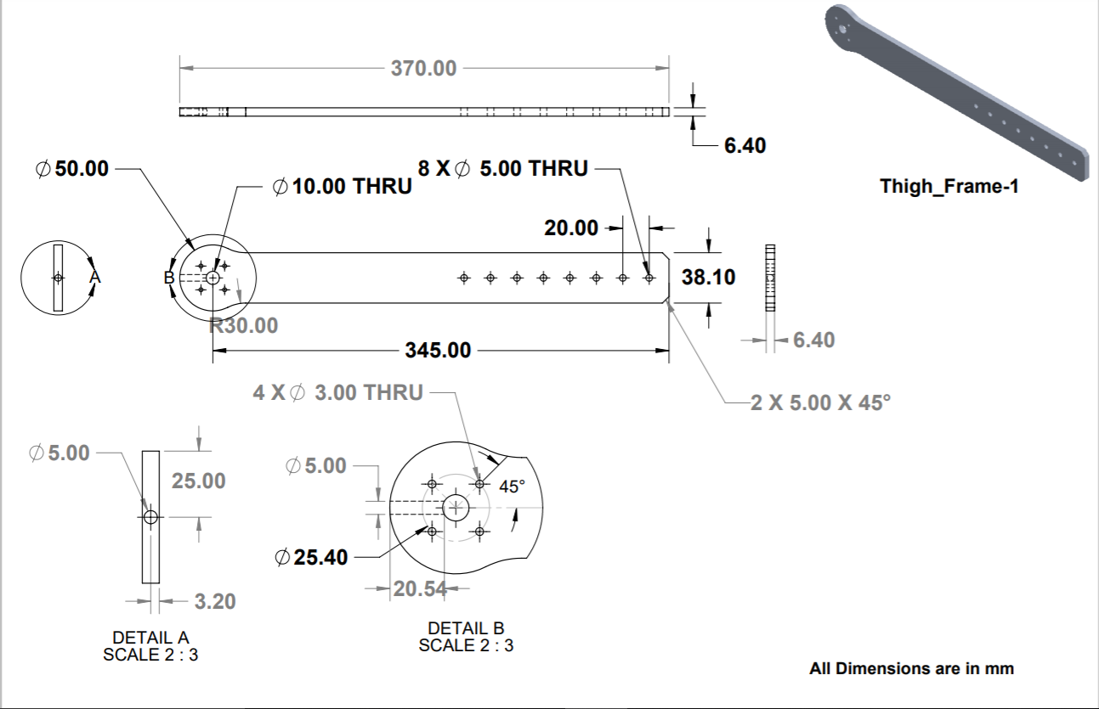

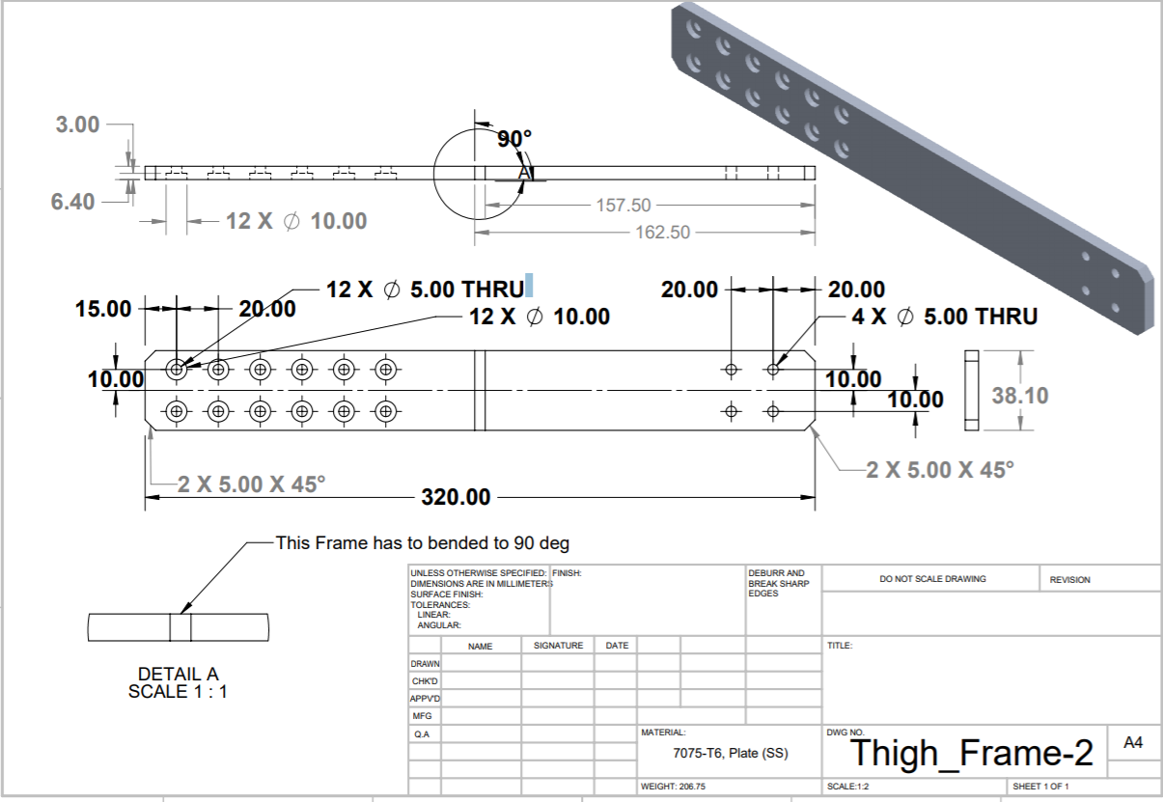

***Knee frames:***

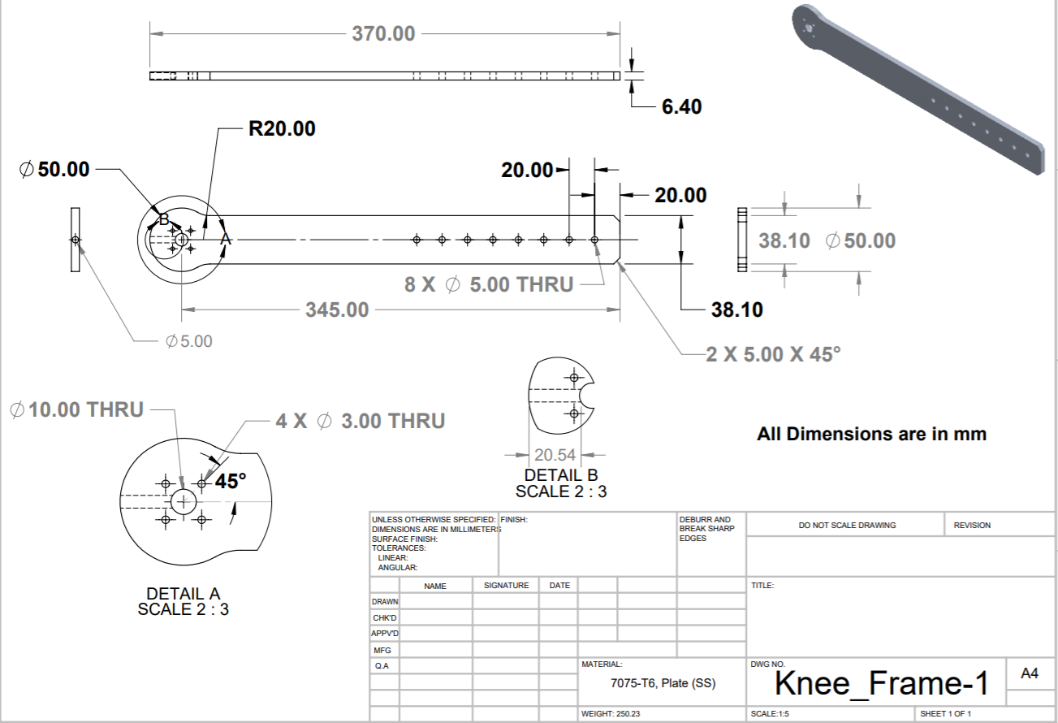

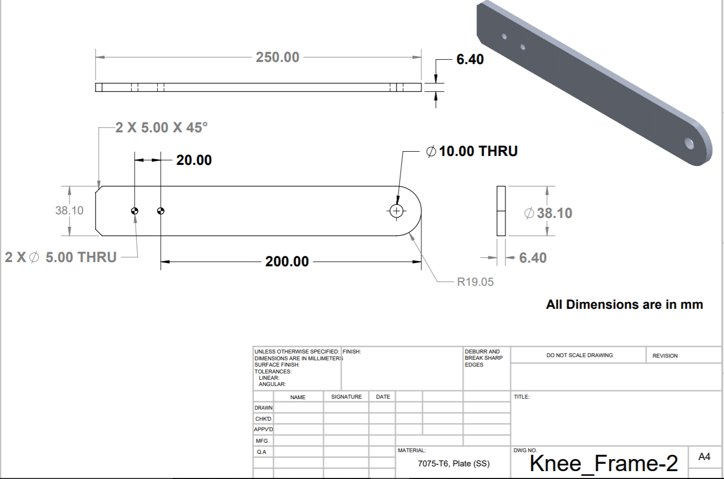

***Flange coupling:***

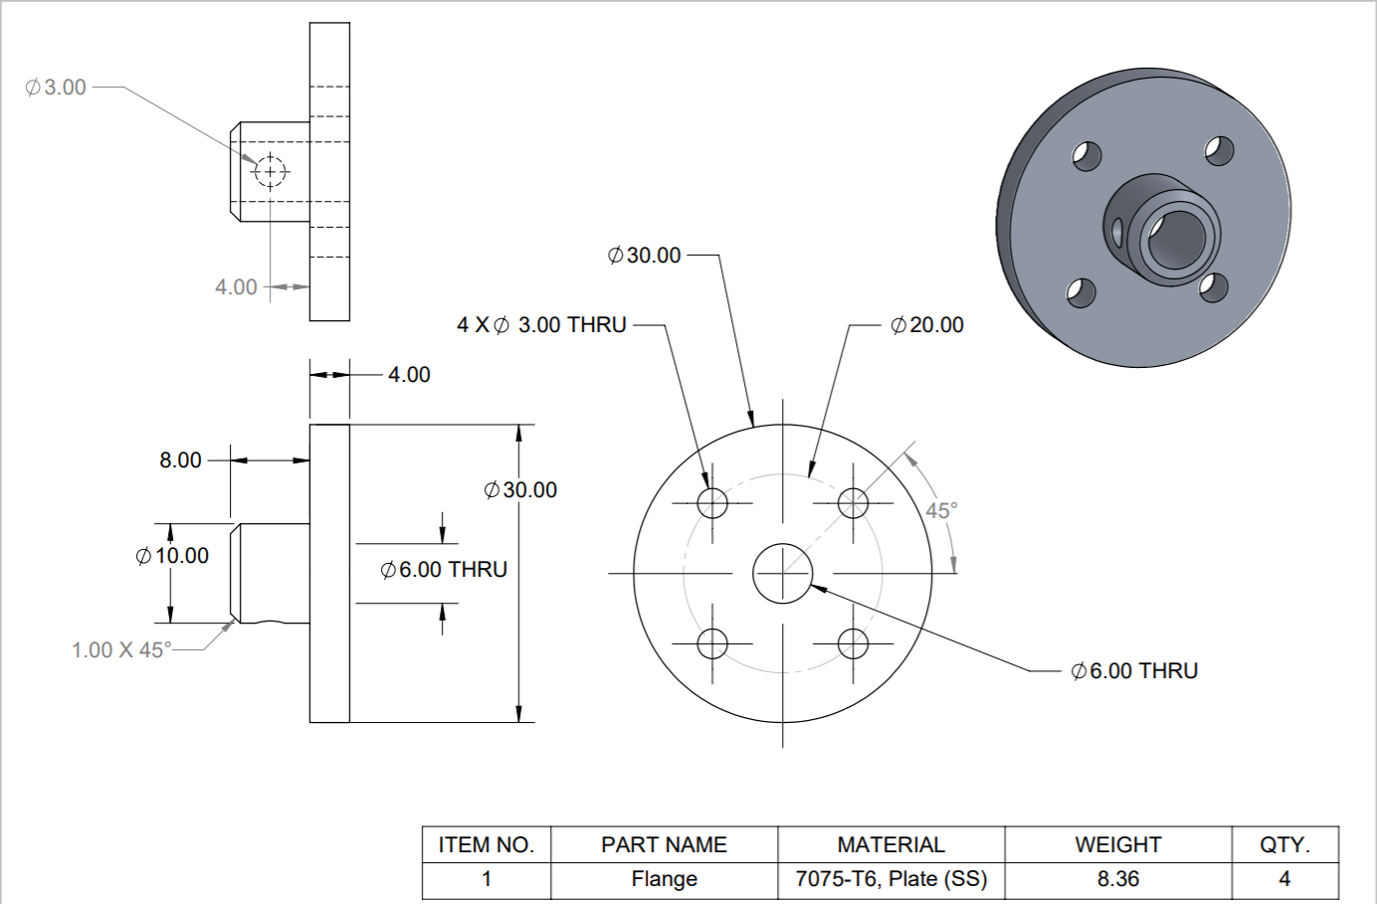

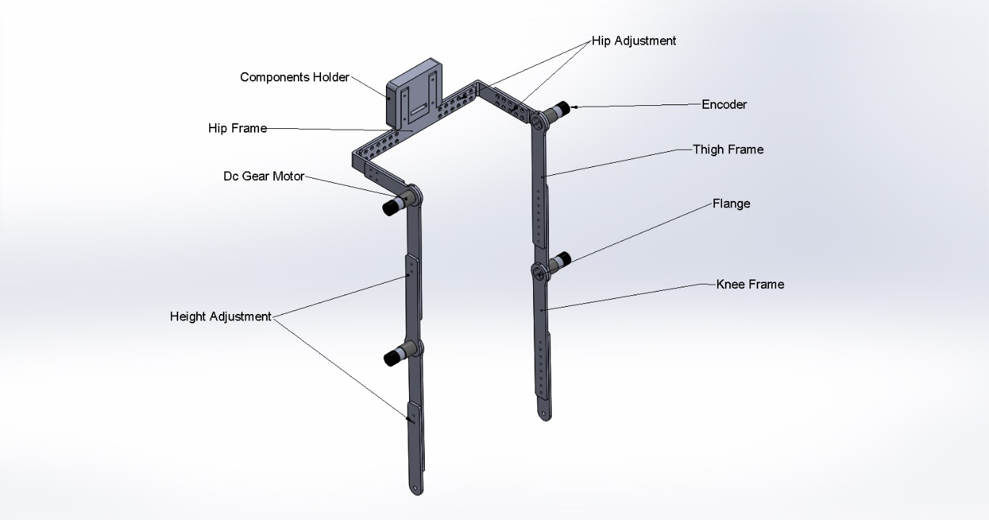

Figure.6.1 CAD Model of Exoskeleton for fabrication

**6.1.1 Height and waist adjustment:**

The exoskeleton is designed in a way that it will adapt to the wearer’s height and waist circumference with the help of nut and bolt fasteners arrangement provided. Height of the exoskeleton can be adjusted between 81cm to 106 cm, with knee frame ranging from (min - 39cm, max - 51.1cm) and thigh frame ranging from (min - 42cm, max - 54cm), see figure 6.2.

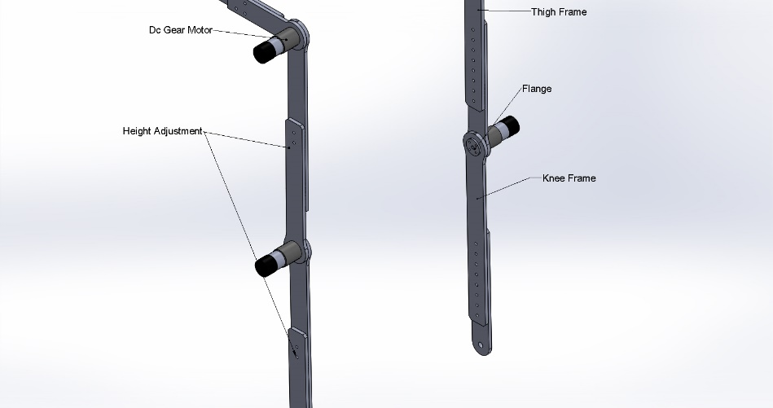

Figure.6.2 Exoskeleton height adjustment

The waist circumference can be adjusted varying between 80 to 106 cm, with hip frame ranging from (min - 41.7cm, max - 55.7 cm) and hip front ranging from (min - 19.75 cm, max - 27.5cm), see figure 6.3.

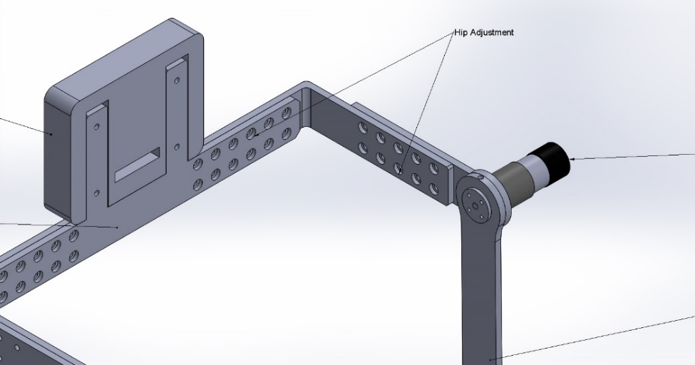

Figure.6.3 Exoskeleton waist adjustment

**6.1.2 Flange Coupling:**

To mount the motor with the exoskeleton a flange coupling is used in the design, see figure 6.4. The flange coupling will hold the shaft of the motor and transmit the power to the frames. A through hole is made on the flange and the shaft, and a nut is used to fix the frame, flange and the shaft rigidly, see figure 6.5.

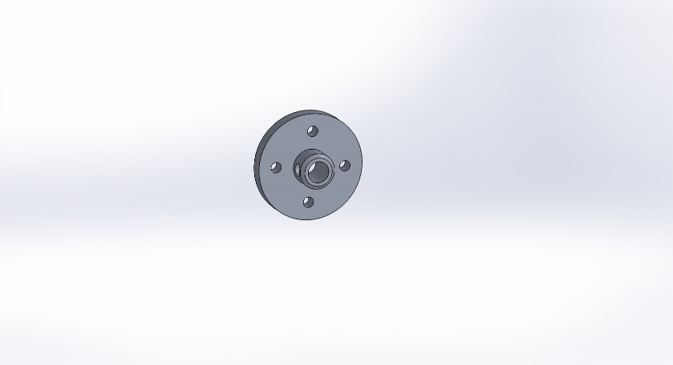

Figure.6.4 Flange Coupling

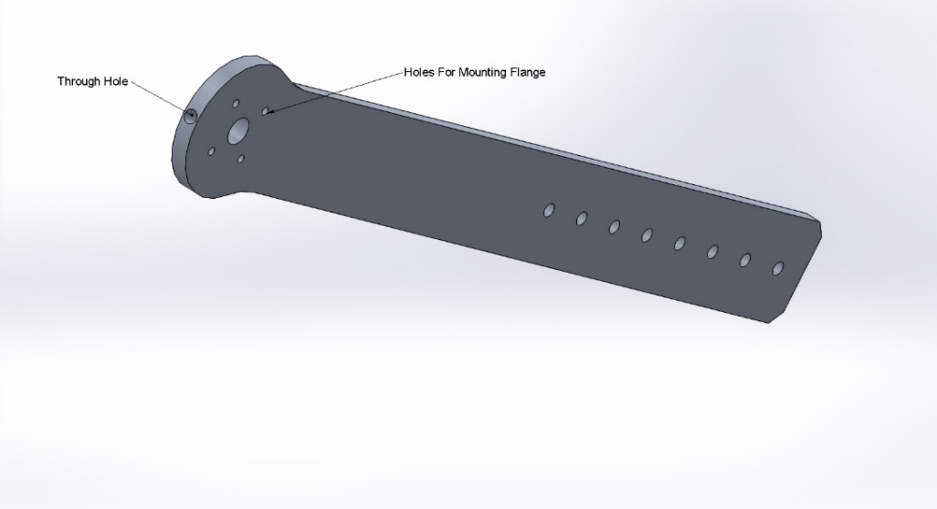

Figure.6.5 Through hole

**6.2 Components for Exoskeleton:**

**6.2.1 Microcontroller holder:**

This holder provides room for microcontroller and motor driver shield and separates these electronic components from being in contact with the wearer for better safety. This holder is 3D printed by using ABS (Acrylonitrile butadiene styrene) material and with the help of FDM (Fused Deposition Modeling).

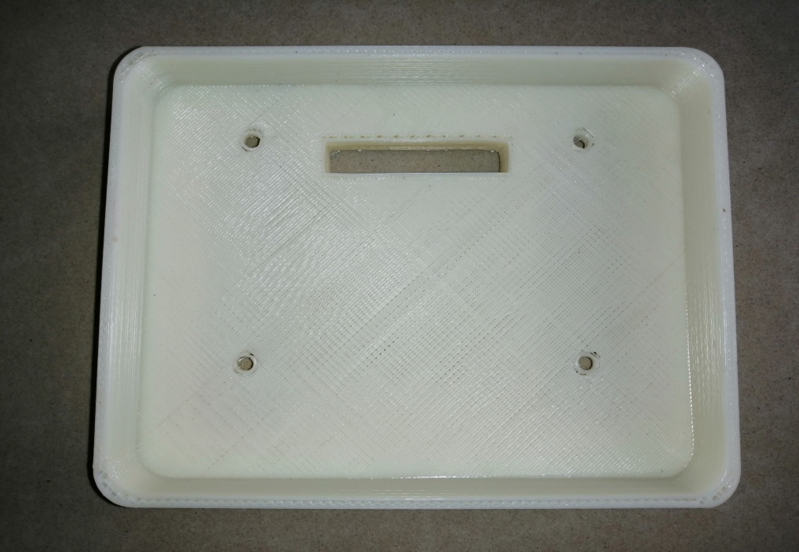

Figure.6.6 Microcontroller holder

**6.2.2 Motors:**

The exoskeleton is actuated with the help of motors which are fixed at the joints. The Rhino Planetary Geared Quad Encoder 10 RPM DC Servo Motor is used in this model. This motor comes along with gear box and encoders. Encoders can measure angular movement, both degree of movement and direction. The specification of this motor is shown in table.6.1.

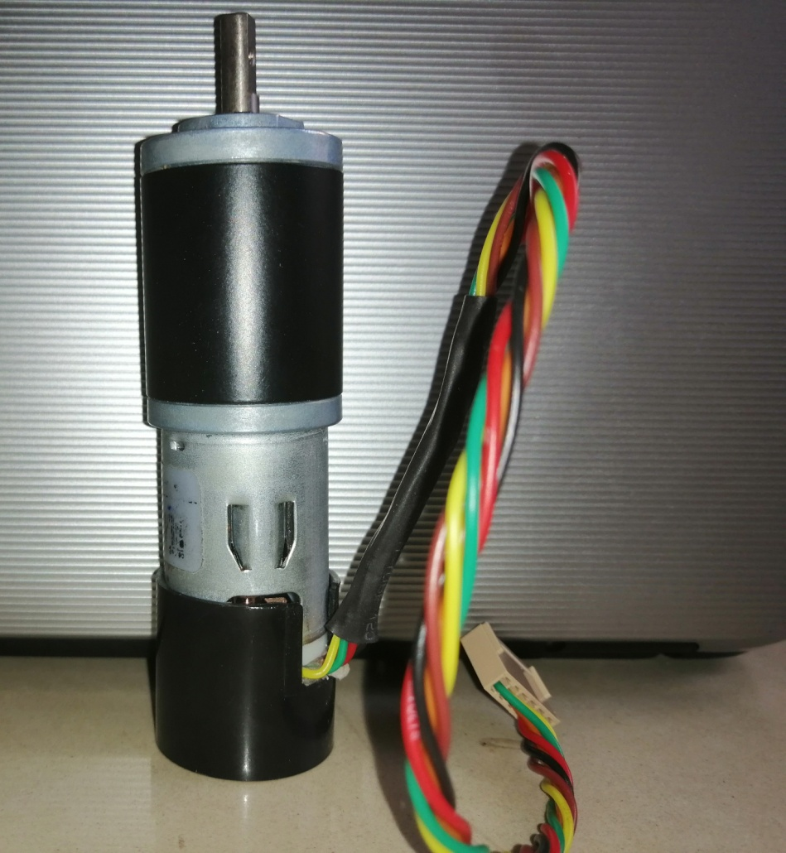

Figure.6.7DC Servo Motor

|  |  |
| --- | --- |
| **Parameters** | **Units** |
| Speed of motor | 1800rpm |
| Speed of motor with gear box | 10rpm |
| Voltage | 12v |
| Rated torque | 140Kg-cm |
| Weight | 300gm |
| Shaft diameter | 6mm |
| Shaft length | 16mm |
| Motor diameter | 28.5mm |
| Gear box diameter | 32mm |

Table 6.1 Specifications of motor

**6.2.3 Microcontroller:**

Exoskeleton is controlled with the help of Arduino UNO. The Arduino UNO is an open-source microcontroller board based on the Microchip ATmega328P microcontroller and developed by Arduino. The board is equipped with sets of digital and analog input/output (I/O) pins that may be interfaced to various expansion boards (shields) and other circuits. The board has 14 Digital pins, 6 Analog pins, and programmable with the Arduino IDE (Integrated Development Environment) via a type B USB cable. The operating voltage of Arduino Uno is 5v.

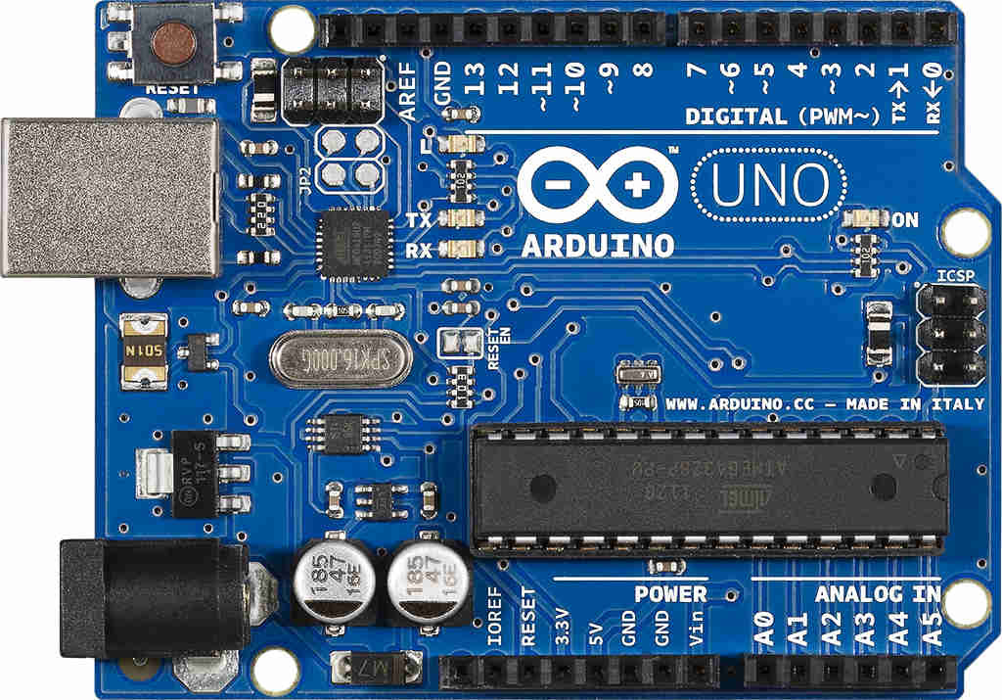

Figure.6.8 Arduino UNO

**6.2.4 Motor Shield:**

The shield contains two L293D motor drivers and one 74HC595 shift register. The shift register expands 3 pins of the Arduino to 8 pins to control the direction for the motor drivers. The output enable of the L293D is directly connected to PWM outputs of the Arduino.

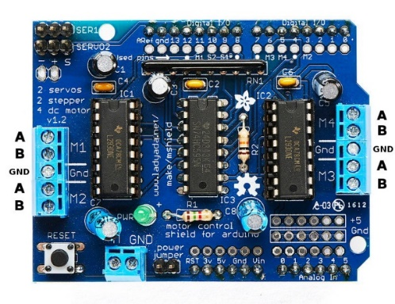

Figure.6.9 Motor driver shield

The Motor Shield is able to drive 2 servo motors, and has 8 half-bridge outputs for 2 stepper motors or 4 full H-bridge motor outputs or 8 half-bridge drivers, or a combination. The servo motors use the +5V of the Arduino board. The voltage regulator on the Arduino board could get hot. To avoid this, the newer Motor Shields have connection points for a separate +5V for the servo motors.

**6.2.5 DC Power supply:**

A power supply is an electrical device that supplies electric power to an electrical load. The primary function of a power supply is to convert electric current from a source to the correct voltage, current, and frequency to power the load. As a result, power supplies are sometimes referred to as electric power converters. Some power supplies are separate standalone pieces of equipment, while others are built into the load appliances that the power.



Figure.6.10. DC power supply

***Cost estimation of the Fabricated exoskeleton:***

|  |  |  |
| --- | --- | --- |
| **Component** | **Quantity** | **Cost** |
| Material(Aluminium 6061) | 11 kg X 375/kg | Rs.4125 /- |
| Motors(DC servo motors) | 4 X 2500 | Rs.10000/- |
| 3D-printed casing | ABS 41 metres + printing cost | Rs.750/- |
| Microcontroller(Arduino Uno) | 1 | Rs.500/- |
| Motor Driver shield | 1 | Rs.1500/- |
| Machining cost |  | Rs.5000/- |
| Dc power supply |  | Rs.2000/- |
|  | Total cost | Rs.23,875 |

Table.6.2 Cost estimation of fabrication

**CHAPTER 7**

**CONCLUSION AND DISCUSSION**

**7.1 Conclusion:**

The lower limb exoskeleton was designed considering the anthropometric data of the elderly in the light of cost and lightweight simple design. The approximate weight of the exoskeleton is 14 kg and still, there is a vast room to maneuver on this factor. The Static Structural Analysis results show that on using Aluminium 7075 T6 as the primary material for the Exoskeleton, the design can withstand a load of 100kg. This analysis is done on both Full exoskeleton design and the Hip frame alone to compare and evaluate the Total deformation and stress distribution. This was done because in the case of Full exoskeleton the maximum stress was acting on the flex spline of the Harmonic drive. The flex spline was defined with the material 15-5 Ph stainless-steel which has a Yield strength of 1070 MPa. To study the behaviour of Aluminium 7075 T6 under the loading conditions, individually the Hip fame was defined with aluminium and the analysis was done. The Hip frame analysis exhibits safe results making the aluminium 7075 T6 as suitable material for the exoskeleton design. On further loading of the exoskeleton with 120kg, 150kg, 245kg, 305kg randomly in a gradually ascending order the maximum stress acting on the exoskeleton is 1025.2 MPa at 305 kg. If we further increase the load, the Maximum stress will be beyond the Yield strength of the 15-5 Ph stainless-steel i.e. 1070 MPa. So, the maximum load the exoskeleton can withstand during the static condition is 305 kg. But, by taking the factor of safety into consideration the maximum weight of the wearer is constrained to 100 kg, which will also satisfy the design requirements for the Indian subject mentioned in the Literature survey. Modal analysis was done to find the natural frequency of the exoskeleton and the deformation of the exoskeleton with respect to mode frequency. This was done to find whether the selected motor will create a resonance, but the results show that the natural frequency vibration of the exoskeleton structure is not in the range of the forced vibrations created by the motor. So, the motor will not create any resonance with the exoskeleton structure. The design satisfied both static structural Analysis and Modal Analysis substantiating that the design is structurally safe.

***Merits of exoskeleton:***

* Simple and cost effective design considering only the vital functions of the elderly gait.
* Lower limb exoskeleton design with the elderly Anthropometric data consideration.
* Ergonomic and comfortable design.
* Usage of Aerospace material (Aluminium 7076 T6) made the design light in weight and robust in strength.

***Limitations of the design:***

* The design is constrained only to 6 degrees of freedom (DOF).
* Level walking cannot be achieved with this design.
* Better height and waist adjustment mechanism needed.
* Requires more developed user interface which help in easy control of the walking speeds depending on the wearers comfort.

A stripped down version of the exoskeleton is designed and fabricated to test the control system algorithms. Since the fabricated exoskeleton is designed for the experimental purposes only its usage is constrained to laboratory environment.

**References**

[1] A. Zoss, H. Kazerooni, and A. Chu, “On the mechanical design of the Berkeley lower extremity exoskeleton (BLEEX),” in Proc*. IEEE/RSJ Int*. *Conf. Intell. Robots Syst., 2005*, pp. 3132–3139.

[2] H. Kazerooni, Z. Racine, L. Huang, and R. Steger, “On the control of the Berkeley lower extremity exoskeleton (BLEEX),” in Proc*. IEEE Int. Conf. Robot. Autom., 2005*, pp. 4364–4371.

[3] H. Kobayashi and H. Suzuki, “Development of a new shoulder mechanism for a muscle suit,” in Proc. *IEEE/RSJ Int. Conf. Intell. Robots Syst., 2005*, pp. 2727–2732.

[4] Health Issues in Geriatrics, Santosh B Salagre, *Indian geriatrics society*.

[5] Health consequences of obesity in the elderly, 26 January 2014, *Science Direct*.

[6] Gait Disorders in Older Adults,*Neil* B. *Alexander,* MD

[7] Petri Wiklund, The role of physical activity and exercise in obesity and weight management: time for critical appraisal, *Journal of Sport and Health Science*,21 March 2016.

[8] Joe Verghese MD Aaron LeValley MA Charles B. Hall PhD Mindy J. Katz MPH Anne F. Ambrose MD Richard B. Lipton MD, Epidemiology of Gait Disorders in Community‐Residing Older Adults, *Journal of the American Geriatrics Society*, 19 December 2005.

[9]. Aveiro MC; Granito RN; Navega MTI; Driusso PI; Oishi J, Influence of a physical training program on muscle strength, balance and gait velocity among women with osteoporosis, Department of Physical Education, Center for Biological and Health Sciences, Federal University of São Carlos - UFSCar, São Carlos, SP – Brazil.

[10] Atsushi Tsukahara; Yasuhisa Hasegawa; Kiyoshi Eguchi; Yoshiyuki Sankai, Restoration of Gait for Spinal Cord Injury Patients Using HAL with Intention Estimator for Preferable Swing Speed, *IEEE Transactions on Neural Systems and Rehabilitation Engineering*, 23 October 2014.

[11] Adam B. Zoss, H. Kazerooni, Member, IEEE, and Andrew Chu, Biomechanical Design of the Berkeley Lower Extremity Exoskeleton (BLEEX), *IEEE/ASME TRANSACTIONS ON MECHATRONICS*. 2, APRIL 2006.

[12] Alberto Esquenazi MD Mukul Talaty PhD Arun Jayaraman PT, PhD, Powered Exoskeletons for Walking Assistance in Persons with Central Nervous System Injuries: A Narrative Review, 15 July 2016.

[13] Ryan J. Farris, Hugo A. Quintero, and Michael Goldfarb, Performance Evaluation of a Lower Limb Exoskeleton for Stair Ascent and Descent with Paraplegia, *34th Annual International Conference of the IEEE EMBS San Diego, California USA*, 1 September, 2012.

[14] Esquenazi, Alberto MD; Talaty, Mukul PhD; Packel, Andrew PT, NCS; Saulino, Michael MD, PhD, The ReWalk Powered Exoskeleton to Restore Ambulatory Function to Individuals with Thoracic-Level Motor-Complete Spinal Cord Injury, *American Journal of Physical Medicine & Rehabilitation*, November 2012.

[15] Magdo Bortole, Anusha Venkatakrishnan, Fangshi Zhu, Juan C Moreno, Gerard E Francisco, Jose L Pons and Jose L Contreras-Vidal, The H2 robotic exoskeleton for gait rehabilitation after stroke: early findings from a clinical study, *JOURNAL OF NEUROENGINEERING AND REHABILITATION,*17 June 2015.

[16] Hageman P A, Blanke D J. Comparison of gait of young women and elderly women. Ph.vs Ther 1986; 66: 1382- 1387.

[17] Winter D A,The Biomechanics and Motor Control of Human Gait: Normal, Elderly and Pathological, *2nd edition. Waterloo: University of Waterloo Press*, 1991.

[18] Oberg T, Karsznia A. ijberg K;Basic parameters: Reference data for normal subjects. IO-79 years of age *Rehabil Res Dev 1993*.

[19] Hageman P A;Gait characteristics of healthy elderly: a literaturereview; Issues Aging 1995; 18: 14- 17.

[20] Finley F R, Cody K A, Finizie R V; Locomotion patterns in elderly women; Arch Phys Med Rehabil 1969; 50: 140-146.

[21] Waters R L, Lunsford B R, Perry J. Byrd R; Energy-speed relationship of walking: standard tables; J Orthop Res 1988; 6:2155222.

[22] Prudham D, Evans J G; Factors associated with falls in the elderly: a community study; Age Ageing 1981.

[23] Karen M Ostrosky, Jessie M VanSwearingen, Ray G Burdett, Zena Gee; A Comparison of Gait Characteristics in Young and Old Subjects; *Physical Therapy, Volume 74*; 1 July 1994.

[24] Alberto Esquenazi, Mukul Talaty, Arun Jayaraman; Powered Exoskeletons for Walking Assistance in Persons with Central Nervous System Injuries. A Narrative Review; 15 July 2016.

[25] Yeo Wei Hong, Yeong-Jin King, Wei-Hong Yeo, Chen-Hunt Ting, Yea-Dat Chuah, Jer-Vui Lee and Eu-Tjin Chok, Lower Extremity Exoskeleton: Review and Challenges Surrounding the Technology and its Role in Rehabilitation of Lower Limbs, *Australian Journal of Basic and Applied Sciences*,2013.

[26] Adam B. Zoss, H. Kazerooni, Member, IEEE, and Andrew Chu, Biomechanical Design of the Berkeley Lower Extremity Exoskeleton (BLEEX), *IEEE/ASME TRANSACTIONS ON MECHATRONICS*. 2, APRIL 2006.

[27] Susan Karlin; Raiding Iron Man's closet [Geek Life]; *IEEE Spectrum;* 22 July 2011.

[28] Weiguang Huo, Samer Mohammed, Juan C. Moreno, and Yacine Amirat; Lower Limb Wearable Robots for Assistance and Rehabilitation: A State of the Art; *IEEE SYSTEMS JOURNAL*; 20 October 2014.

[29] ADAM ZOSS and H. KAZEROONI; Design of an electrically actuated lower extremity exoskeleton; *Advanced Robotics;*27 March 2006.

[30] Garrec P., Friconneau J.P., Measson Y., Perrot Y., ABLE, an Innovative Transparent Exoskeleton for the Upper-Limb, *IEEE/RSJ International Conference on Intelligent Robots and Systems*, 2008, 1483–1488.

[31] Chen F., Yu Y., Ge Y., Sun J., Deng X., WPAL for Enhancing Human Strength and Endurance during Walking, *International Conference on Information Acquisition*, 2007, 487–491.

[32] Pratt J.E., Krupp B.T., Morse C.J., Collins S.H., The RoboKnee: An Exoskeleton for Enhancing Strength and Endurance During Walking*, IEEE International Conference on Robotics and Automation*, vol. 3, 2004, 2430–2435.

[33] Aguirre-Ollinger G., Colgate J.E., Peshkin M.A., Goswami A., Design of an Active 1-DOF LowerLimb Exoskeleton with Inertia Compensation, “*The International Journal of Robotics Research*”, vol. 30.

[34] Peter D Neuhaus, Jerryll H Noorden, Travis J Craig, Tecalote Torres, Justin Kirschbaum, Jerry E Pratt; Design and Evaluation of Mina a Robotic Orthosis for Paraplegics; *2011 IEEE International Conference on Rehabilitation Robotics*; July 1, 2011.

[35] Manuel Cestari, Daniel Sanz-Merodio, Juan Carlos Arevalo, and Elena Garcia; An Adjustable Compliant Joint for Lower-Limb Exoskeletons; *IEEE/ASME TRANSACTIONS ON MECHATRONICS*.

[36] Levine DF, Richards J, Whittle M. (2012). Whittle's Gait Analysis; *Elsevier Health Sciences*. ISBN 978-0702042652.

[37] Kadaba, M. P.; Ramakrishnan, H. K.; Wootten, M. E; "Measurement of lower extremity kinematics during level walking". *Journal of Orthopaedic Research*; May 1990.

[38] Chand T. John, Frank C. Anderson, Jill S. Higginson & Scott L. Delp (2012): Stabilisation of walking by intrinsic muscle properties revealed in a three-dimensional muscle-driven simulation, *Computer Methods in Biomechanics and Biomedical Engineering*, 06 Jan 2012.

[39] Gery Colombo, MS; Matthias Joerg, MS; Reinhard Schreier, BNIE, Volker Dietz, MD, Treadmill training of paraplegic patients using a robotic orthosis, *Journal of Rehabilitation Research and Development*, 6, December 2000.

[40] Hiroaki Kawamoto,Yoshiyuki Sankai; Power Assist System HAL-3 for Gait Disorder Person; *International Conference on computers for Handicapped persons*; 04 July 2002.

[41] Fan Y, Yin Y. Active and progressive exoskeleton rehabilitation using multisource information fusion from emg and force-position epp*. IEEE Trans Biomed Eng. 2013*;60(12):3314–321.

[42] Zoss AB. Design of an electrically actuated lower extremity exoskeleton. *Adv Robot*. *2006*; 20:967–88.

[43] Mei-Cheng Li, Li-Rong Wang, Dai-Min Chen, Jing-Jing Tao, Dong Chen, The Static Analysis of Wearable Lower Extremity Exoskeleton Based on ANSYS Workbench*, 2013 IEEE 9th International Conference on Mobile Ad-hoc and Sensor Networks*, 30 January 2014.

[44] Gao Dongqiang,Tian Zhenya,Hao Dajian,Yao Sufen;Dynamic Characteristics Analysis of Leading Screw Based on ANSYS Software[J];*Hoisting and Conveying Machinery*,2008(11):54-57.